

Royal School of Life Sciences (RSLSC)
Department Of Forestry
Course Structure & Syllabus
(Based on NEP-2020)

B.Sc. Forestry
(4-years Single Major)

W.E.F.
AY-2024-25

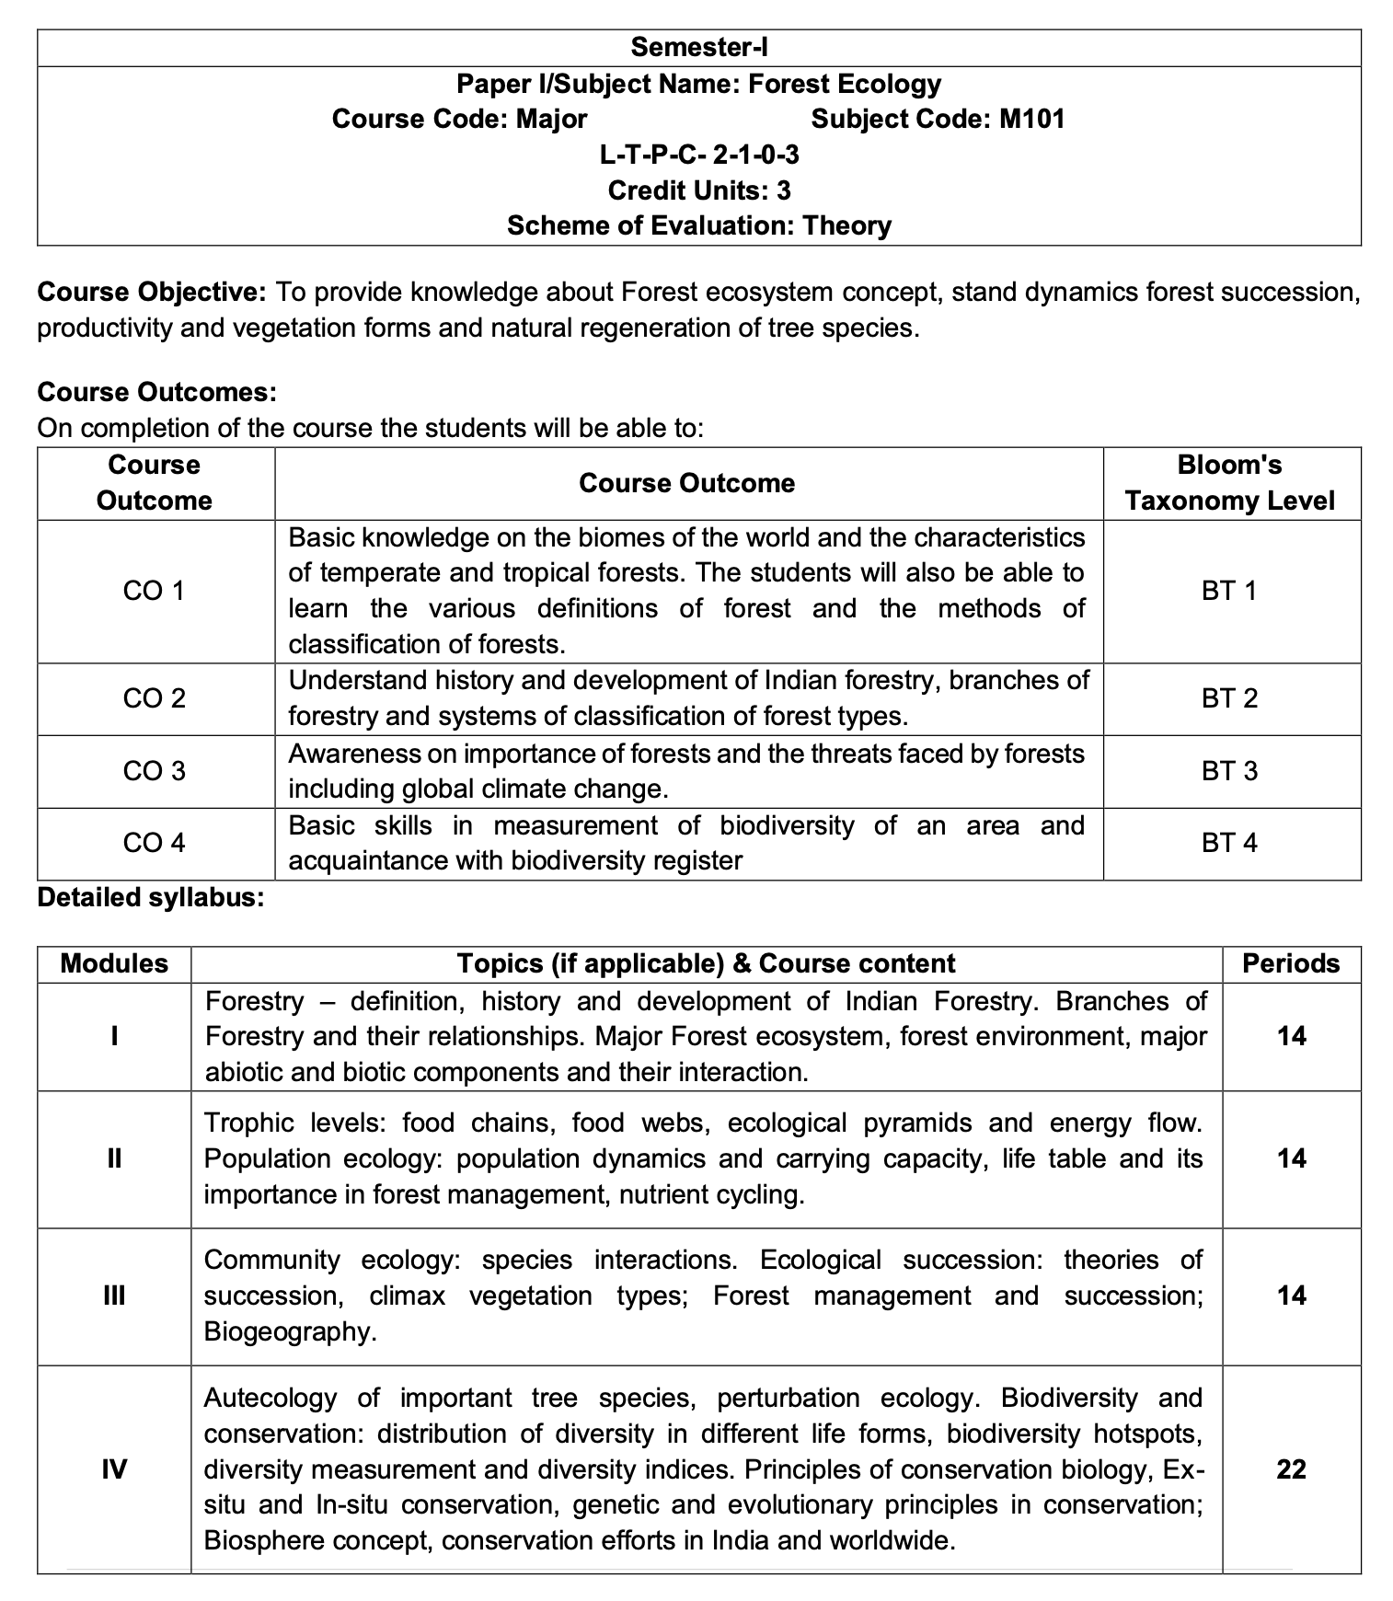
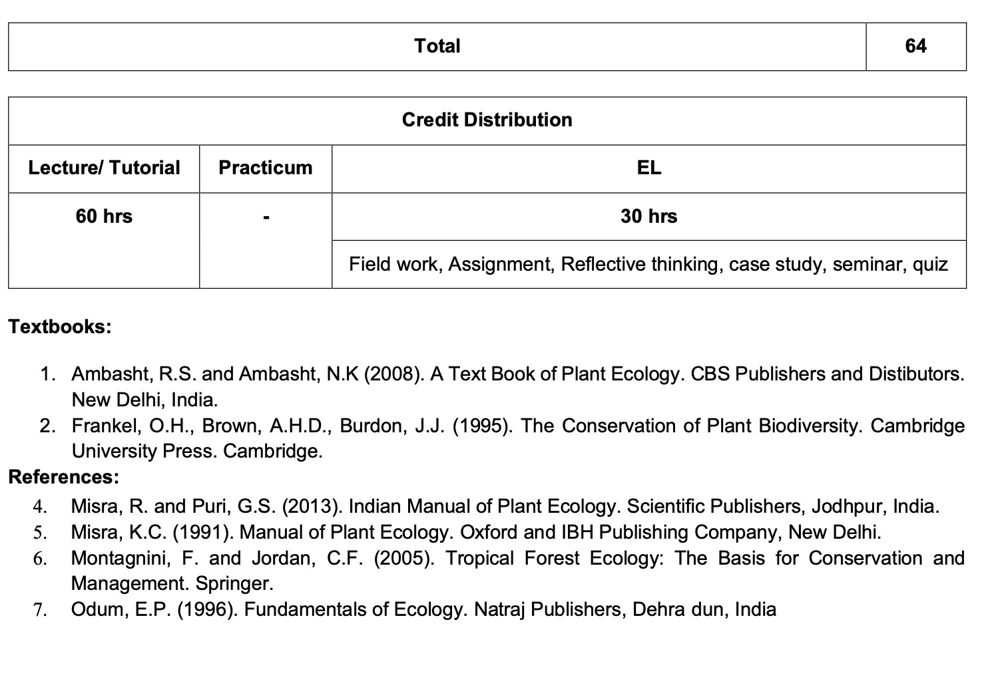
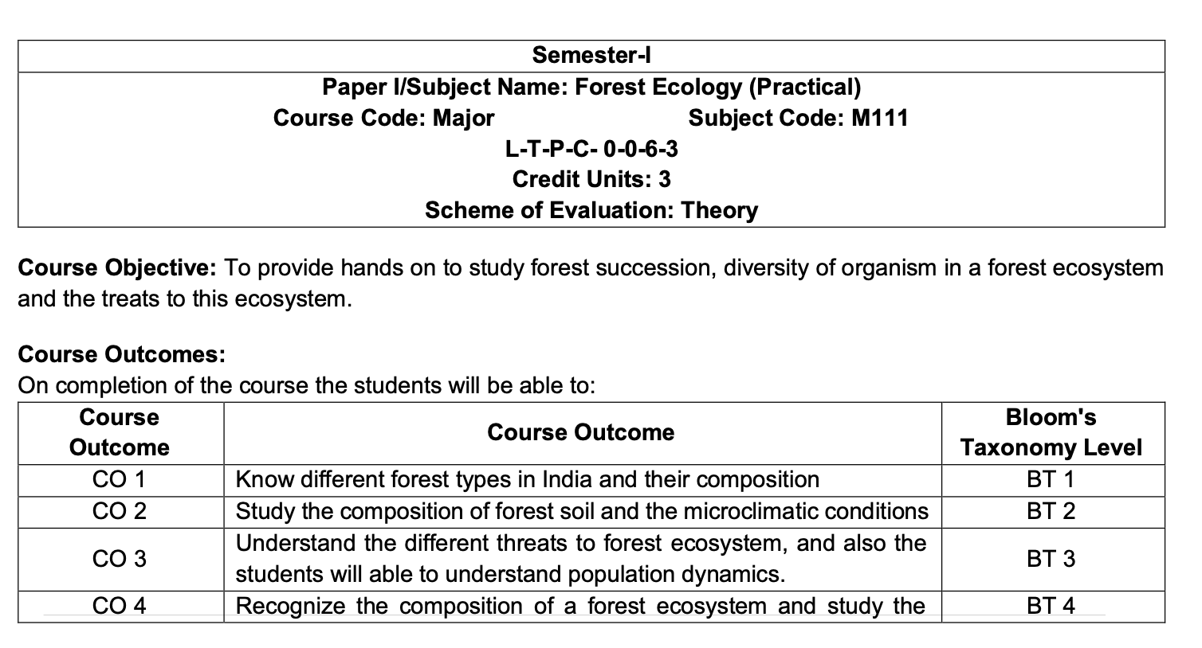

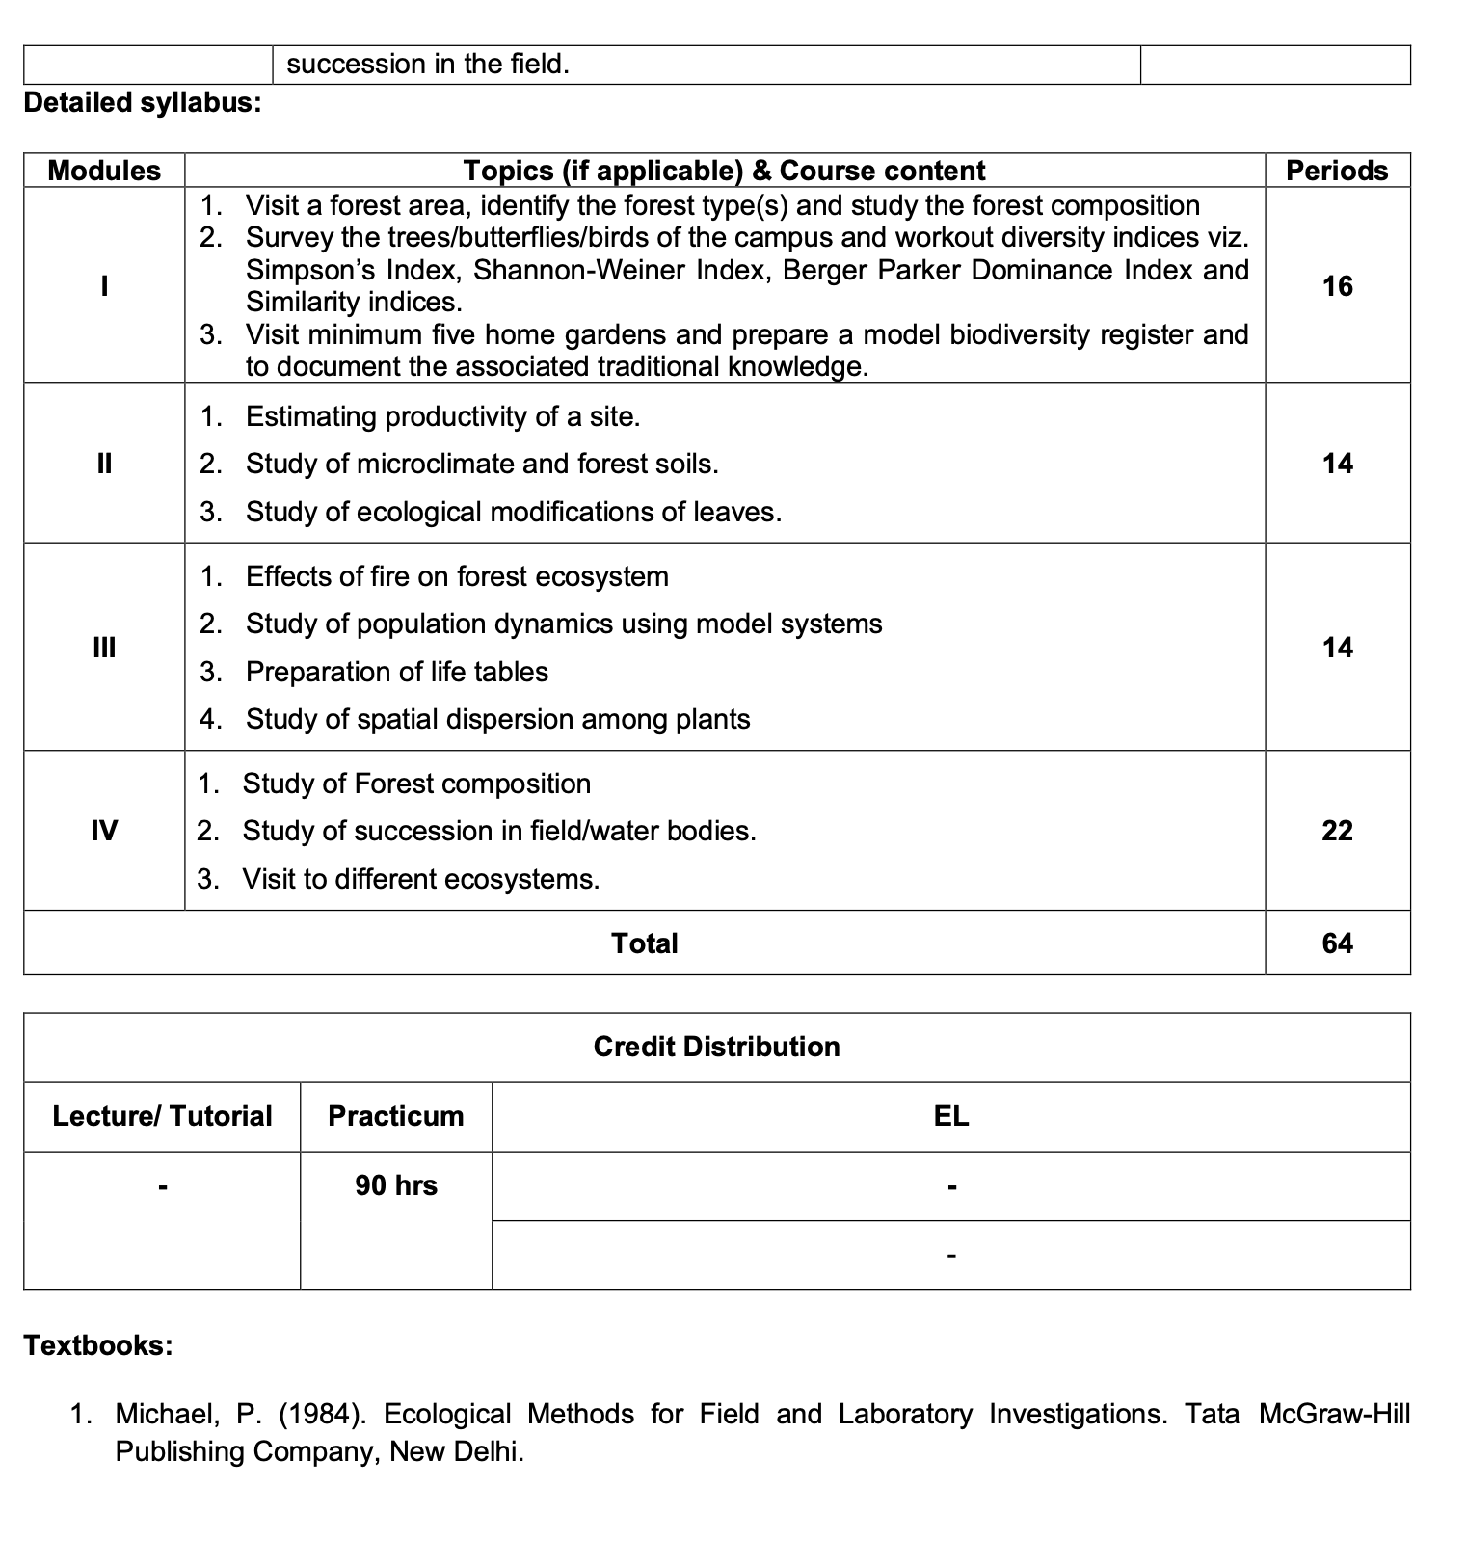

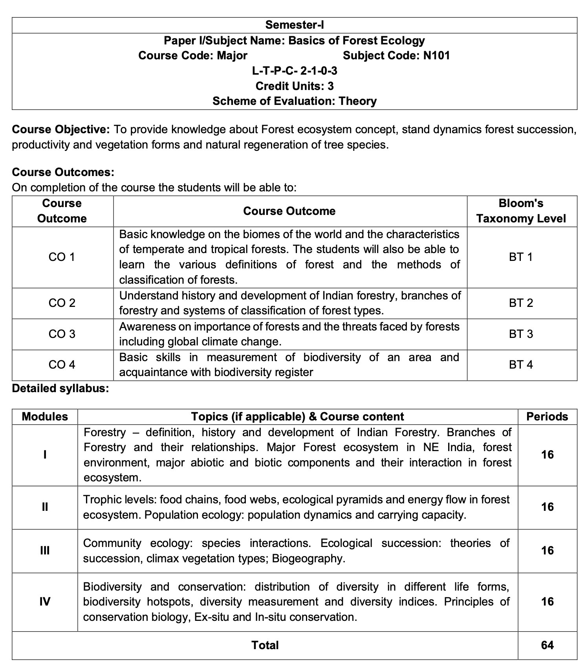

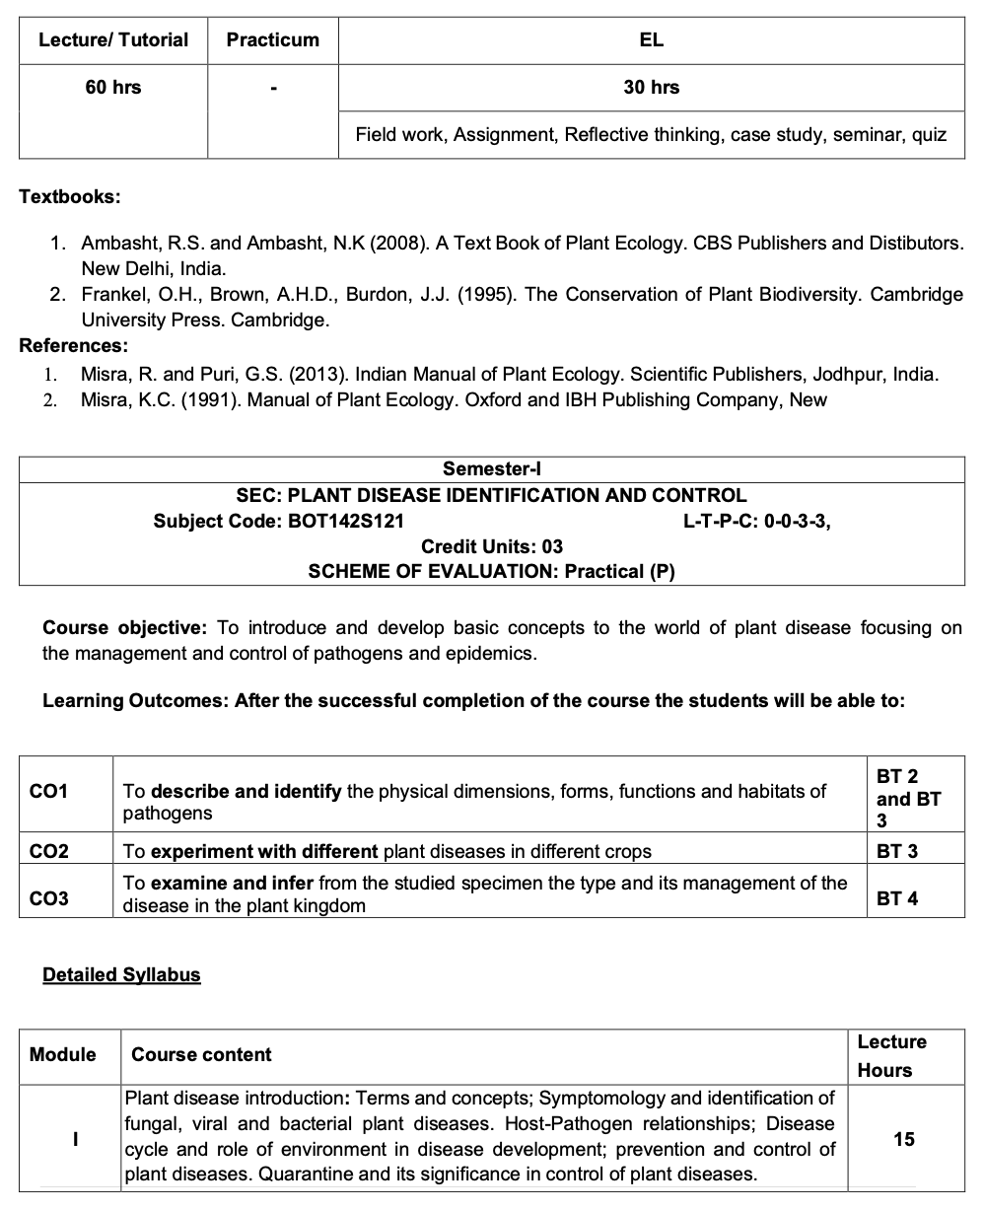

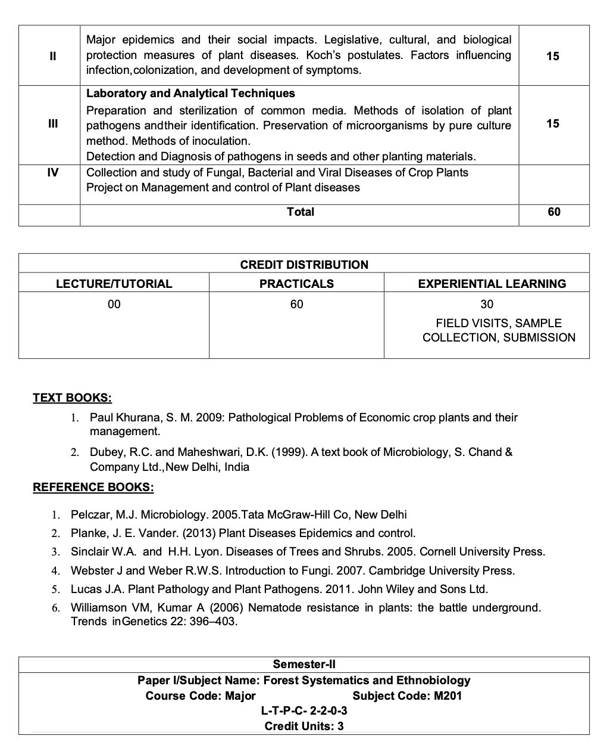

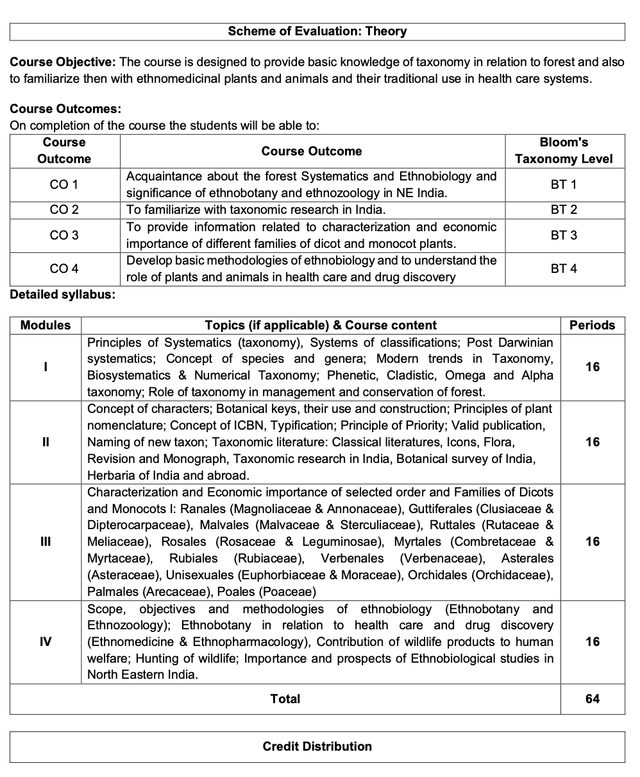
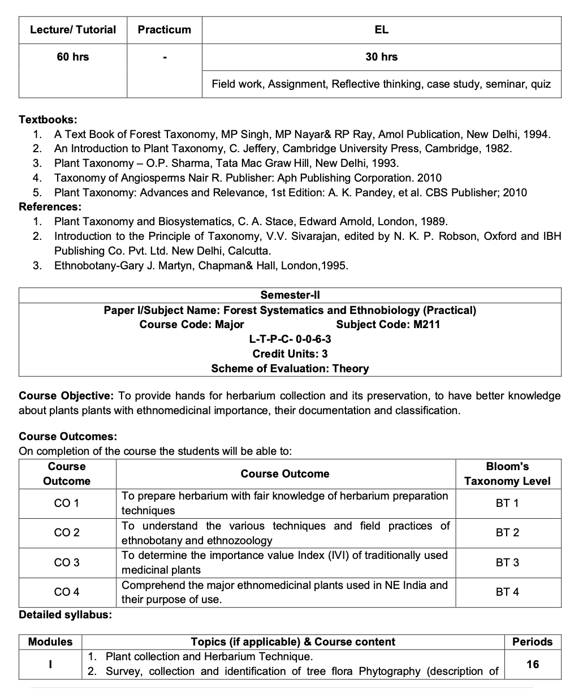

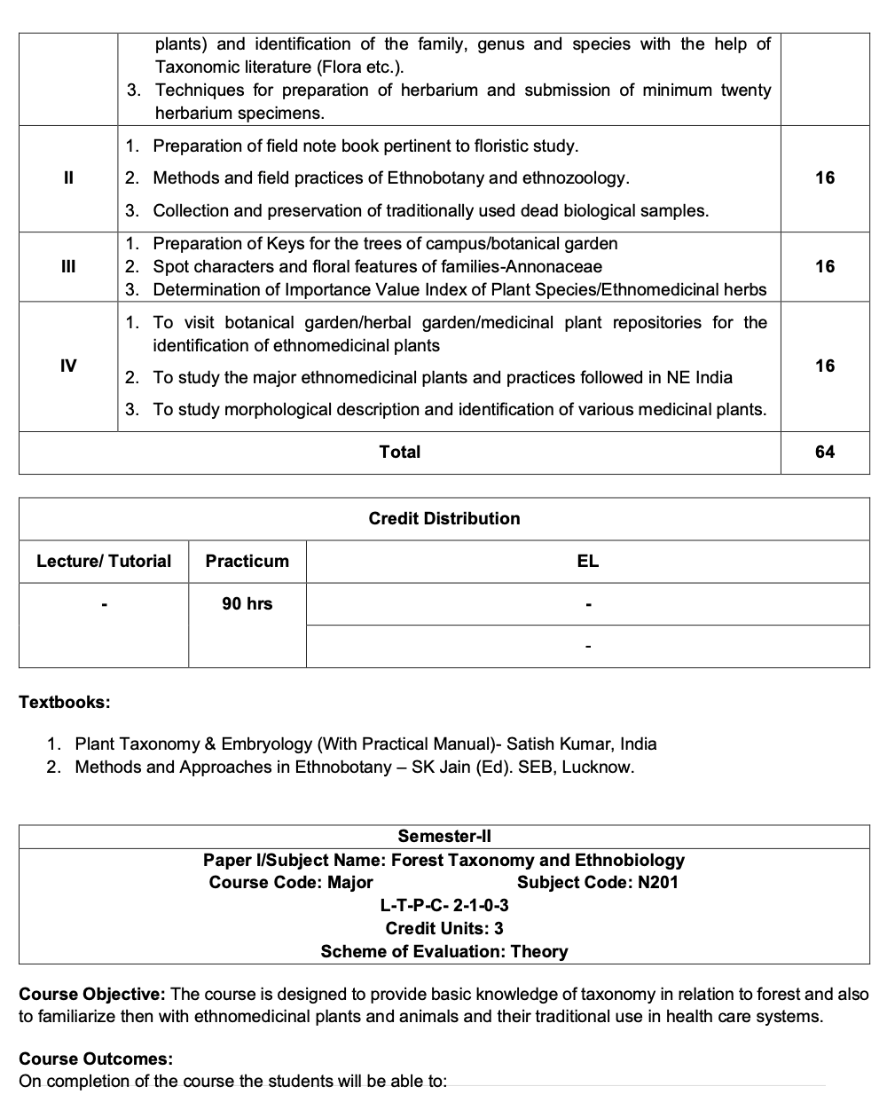
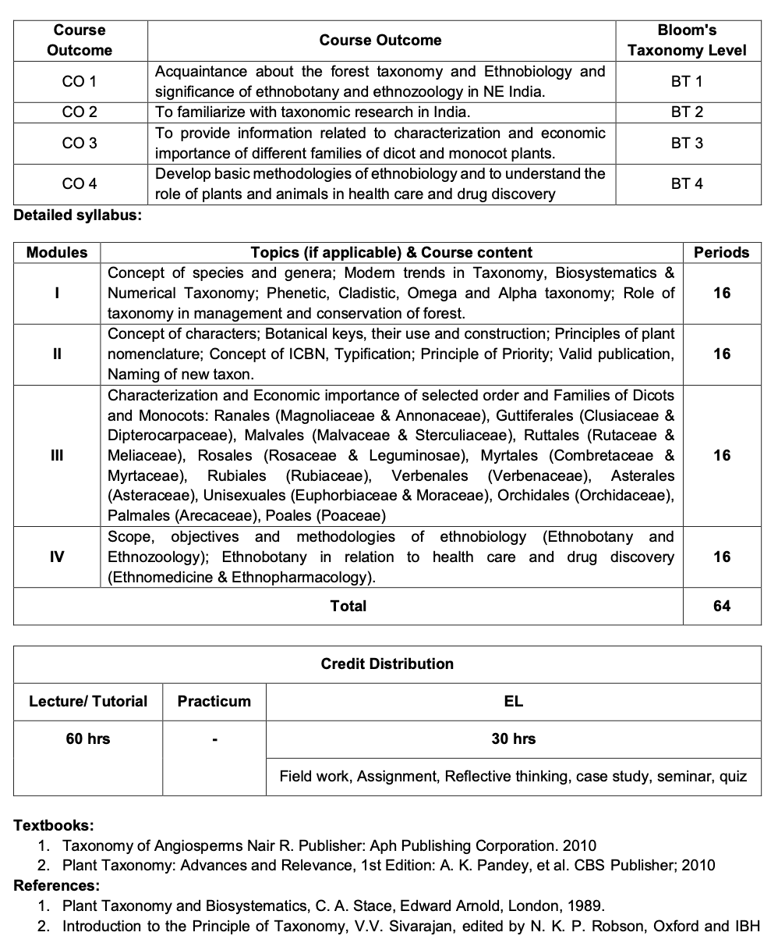

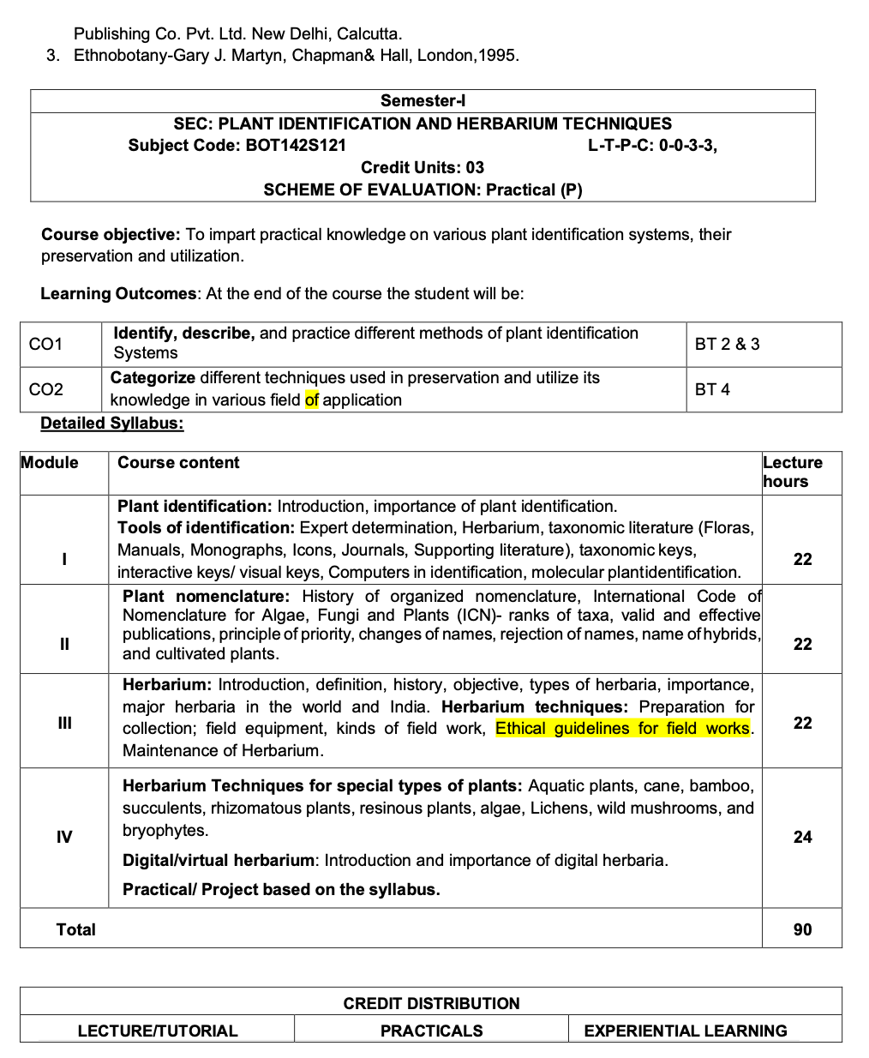
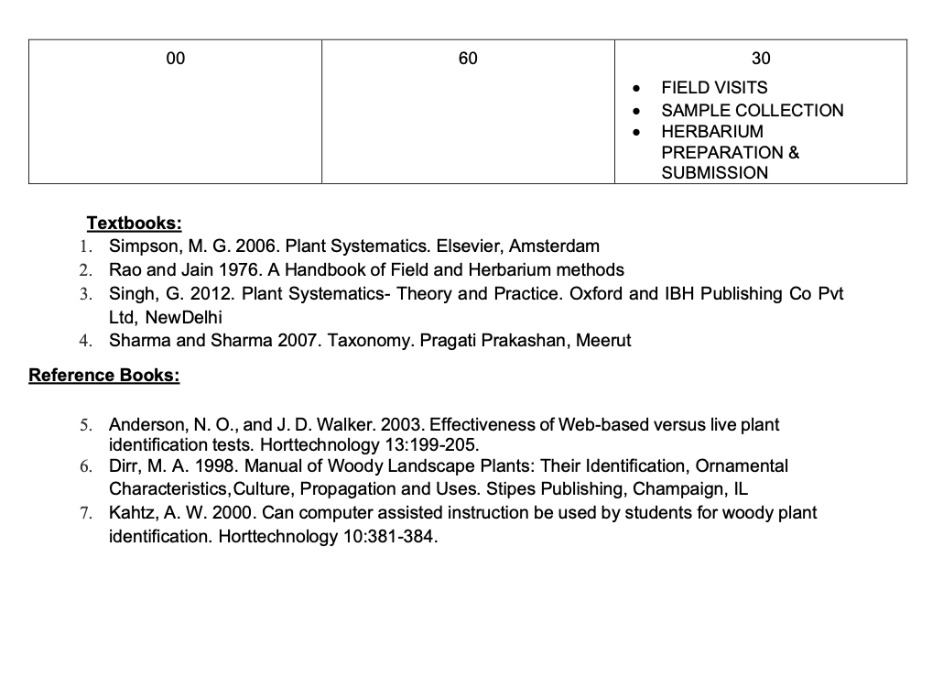
B. Sc. Course in Forestry: Semester-III
Paper I Major | Forest Mensuration  L-T-P-C: 2-1-1-4 Credit Unit: 4 Evaluation Scheme: T+P | Course Code FOR142M301
Course Objective:
This course aims to provide students with foundational knowledge and practical skills in forest mensuration, including measurement techniques, growth analysis, and advanced applications essential for managing forest resources effectively.
Course Outcome:
On successful completion of the course, the students will able to: |  | Bloom’s cognitive level
CO1 | Define key concepts in forest mensuration, including objectives, measurement scales, and units of measurement. | 1
CO2 | Explain the principles of tree form, area measurement, and the significance of precision, accuracy, and bias in forest measurements. | 2
CO3 | Identify different methods and instruments used for measuring diameter, girth, height, and volume of trees. | 3
CO4 | Analyze the impact of measurement errors on forest management decisions and evaluate the effectiveness of various mensuration techniques in forest growth analysis. | 4
Detailed Syllabus
Modules | Title of Unit and Contents | Hours
I | Fundamentals of Forest Mensuration and Measurement Techniques  Forest Mensuration: Definition and objectives; scales of measurement; units of measurements; precision, bias, and accuracy.  Measurement of Diameter and Girth: Place of measurement; rules governing breast height (BH) measurements; instruments used in measurements; diameter and girth classes.  Measurement of Height: Definitions; methods of height measurement including ocular, non-instrumental, and instrumental methods; sources of error in height measurements, including leaning trees. | 16
II | Tree Form, Area, and Volume Estimation  Tree Stem Form: Metzger’s theory; form factor; types of form factor; form height quotient; form class.  Estimation of Area: Cross-sectional area, basal area, and bole surface area.  Volume Estimation: Methods of measuring the volume of standing trees, logs, and branch wood; formulae involved; definitions.  Volume Tables: Preparation of volume tables using graphical and regression methods. | 16
III | Tree Growth and Increment Analysis  Determination of Growth of Trees: Concepts of increment, Current Annual Increment (CAI), Mean Annual Increment (MAI), and increment percent.  Determination of Tree Age and Growth: Techniques for determining the age of trees and the classification of increments.  Measurement of Tree Crops: Objectives; measurement of crop diameter, crop height, crop age, and crop volume. | 16
IV | Advanced Measurements and Practical Applications  Practical Applications:  Calculation of volume of felled and standing trees.  Preparation of volume tables.  Application of different sampling methods.  Preparation of yield and stand tables.  Quantification of regeneration and stand establishment.  Measurement of crown density and crown ratios.  Crown profiling of trees and stands.  Dendrochronological studies. | 16
 | Total | 64
Textbooks:
1. Chaturvedi, A.N and L.S. Khanna (2011). Forest Mensuration and Biometry (5th edition). Khanna Bandhu. Dehra Dun.
2. Forest Mensuration: A Handbook for Practitioners. 2006. Forestry Commission Publications.
3. Husch, B., Beers, T.W. and Kershaw, J. J.A. (2002). Forest Mensuration (4th edition). John Wiley & Sons, Nature.
Reference Books:
- Laar, V. A. and Akca, A. (2007). Forest Mensuration. Managing Forest Ecosystems. Vol.13. Springer.
- Manikandan, K. and Prabhu, S. (2012). Indian Forestry. Jain Brothers. New Delhi.
- West, P.W. (2009). Tree and Forest Measurement (2nd edition). Springer.

Paper II Major | Silviculture & Nursery Technology  L-T-P-C:3-1-0-4 Credit Unit:4 Evaluation Scheme: T | Course Code  FOR142M302
Course Objective: The course aims to provide students with a comprehensive understanding of forest nursery and regeneration techniques, including the principles of silviculture, nursery establishment, and advanced propagation methods.

Course Outcome:
On successful completion of the course, the students will able to: |  | Bloom’s cognitive level
CO1 | Define key terms related to forestry, silviculture, and nursery management | 1
CO2 | Explain the significance of site factors, tree growth patterns, and nursery establishment principles | 2
CO3 | Utilize the ability to establish a forest nursery, including site selection, nursery layout, seed sowing, and the application of growth management techniques such as fertilization and root culturing. | 3
CO4 | Examine various nursery techniques, and their advantages and disadvantages in different forest regeneration scenarios. | 4
Detailed Syllabus
Modules | Title of Unit and Contents | Hours
I | Introduction to Forestry and Regeneration  Forests and Forestry: Definitions, significance, and overview of forestry.  Silviculture: Objectives, scope, and its relation with other branches of forestry.  Site Factors: Overview of climatic, edaphic, physiographic, biotic factors, and their interactions influencing forest sites.  Regeneration Techniques: Overview of natural and artificial regeneration; objectives, advantages, disadvantages, and factors influencing the choice of regeneration techniques. | 16
II | Forest Nursery Establishment and Management  Introduction to Forest Nursery: Definition, scope, and significance of forest nurseries.  Nursery Establishment: Site selection, planning, and layout of nursery areas.  Types of Forest Nurseries: Different types and layouts, including nursery beds and preparation techniques.  Seed Sowing and Growth Management: Methods of seed sowing, mulching, seedling growth, development, and maintenance (pricking, weeding, hoeing, organic matter supplements). | 16
III | Containerized Nursery and Planting Techniques  Containerized Nursery Techniques: Overview, type, and size of containers, merits and demerits of containerized nurseries.  Root Trainer Techniques: Detailed study of root trainer techniques and preparation of ingredient mixtures.  Planting Techniques: Techniques for planting containerized stock, bare-root seedlings, and handling methods for field planting.  Propagation Methods: Overview of vegetative propagation, including budding, grafting, and layering; miniclonal and microcutting technologies. | 16
IV | Nursery Pest and Disease Management  Nursery Pests and Diseases: Identification of important nursery pests and diseases; control measures and management practices.  Modern Nursery Equipment and Tools: Introduction and identification of modern equipment and tools used in nurseries.  Advanced Nursery Operations: Preparation and planting of cuttings, pre-sowing seed treatments, and nursery practices for commercially important tree species.  Nursery Visits and Practical Applications: Visits to forest nurseries, hands-on experience with nursery practices, assessment of nursery conditions, and exposure to best practices in nursery management. | 16
 | Total | 64
Textbooks:
- Agrawal, R.L. (1986). Seed Technology. Oxford - IBH Publishing Co. New Delhi.
- Bewely, J.D and Black, M. (1985). Seed- Physiology of development and germination.
- Bose, T.K.; Mitra, S.K. and Sadhu, M.K. (1986). Propagation of tropical and sub-tropical Horticultural crops.NayaPrakash, Calcutta.
- Chin, H.F. and Roberts, E.H. (1980). Recalcitrant Crop Seeds. Tropical Press Sdn. Bhd. Kuala Lumpur - 22-03, Malaysia.
- Evans, J. and Turnbull, J.W. (2004). Plantation Forestry in the Tropics. 3rd edition. Oxford University Press.
Reference Books:
- Hartmann, H.T. and Kester, D.E. (1968). Plant propagation – principles and practice prentice – Hall of India Private Limited, New Delhi.
- ISTA (1993). International Rules for Seed Testing Rules. International Seed Testing Association, Zurich, Switzerland, 1993.
- Khullar, P. et al. (1992). Forest Seed. ICFRE, New Forest, Dehra Dun.
- Leadem, C.L. (1984). Quick Tests for Tree Seed Viability. B.C. Ministry of Forests and Lands, Canada.
- Napier, I. and Robbins, M. (1989). Forest Seed and Nursery Practice in Nepal. Nepal-UK Forestry Research Project, Kathmandu.
- 11. Prakash, R. (1990). Propagation Practices of Important Indian Trees. International Book Distributors, Dehra Dun.

Paper SEC | Geology & Soil science  L-T-P-C:2-1-1-3 Credit Unit:3 Evaluation Scheme: T+P | Course Code FOR142S31
Course Objective:
This course aims to introduce students to the fundamental concepts of soil science, including geology, soil formation, physical and chemical properties of soils, and measurement techniques.
Course Outcome:
On successful completion of the course, the students will able to: |  | Bloom’s cognitive level
CO1 | Define key terms related to soil science, such as soil formation, physical and chemical properties, and types of soil water. | 1
CO2 | Explain the processes of soil formation, the significance of soil properties like texture, structure, and porosity, and their influence on soil function. | 2
CO3 | Identify different soil-forming minerals, weathering processes, and soil classification systems. | 3
CO4 | Apply measurement techniques to analyse soil properties, including texture, pH, and water content, using laboratory and field methods. | 4
Detailed Syllabus
Modules | Title of Unit and Contents | Hours
I | Introduction to Geology and Soil Formation  Introduction to Geology: Definition, significance, and the composition of the earth’s crust.  Soil as a Natural Body: Major components by volume; pedology, and rock types; Soil Forming Minerals: Definition, classification of minerals including silicates, oxides, carbonates, sulphides, and phosphates; their occurrence and importance in soil formation.  Weathering of Rocks and Minerals: Factors involved, weathering indices, and their impact on soil formation; Factors of Soil Formation: Parent material, climate, organisms, relief, and time; Soil Forming Processes: Eluviation, illuviation, and the formation of various soils.  Soil Classification: Elementary knowledge of soil classification, soil orders, forest soil characteristics, and their distinguishing features compared to agricultural soils. | 16
II | Physical Properties of Soils  Soil Texture: Definition, methods of textural analysis, Stokes' law, and use of the textural triangle; Specific Gravity: Absolute specific gravity, apparent specific gravity/bulk density, factors affecting them, and their relationship; Pore Space: Definition, factors affecting capillary and non-capillary porosity; Soil Colour: Significance, colour variables (hue, value, chroma), and use of Munsell colour chart; factors influencing soil colour including parent material, soil moisture, and organic matter; Soil Structure: Definition, classification, factors influencing soil structure genesis, and soil consistency; Soil Plasticity and Atterberg’s Constants: Understanding soil plasticity, liquid limit, plastic limit, and shrinkage limit.  Soil Air and Temperature: Composition of soil air, factors influencing the amount of air space; sources and distribution of soil heat, factors affecting soil temperature, and measurement techniques. | 16
III | Chemical Properties of Soils  Soil Colloids: Organic colloids (humus), inorganic colloids (secondary silicate clay, hydrous oxides), and their roles in soil properties; Soil Organic Matter: Decomposition process and impact on soil fertility; Soil pH: Concept, soil acidity, nutrient availability, and soil buffering capacity; Problematic Soils: Overview of saline, sodic, and calcareous soils, their characteristics, and management strategies; Study of soil profiles of various parts of India.  Importance of soil health on plant growth (humification, mineralization, decomposition etc). | 16
IV | Soil Water and Practical Applications  Soil Water: Forms of soil water, soil moisture content, hygroscopic coefficient, wilting point, field capacity, moisture equivalent, and maximum water holding capacity.  Energy Concepts and Soil Water Measurement: pF scale, gravimetric methods, electric methods, tensiometer, pressure plate, and pressure membrane apparatus; use of neutron probes.  Soil Water Movement: Understanding saturated and unsaturated flow, infiltration, and percolation.  Practical Applications:Mechanical analysis of soil; Determination of pH, organic carbon (C), cation exchange capacity (CEC); Analysis of available micro and macro nutrients.  Formulating manurial schedules for different soil types. | 16
 | Total | 64
Textbooks:
1. Biswas, T.D. and Mukherjee, S. K. (1987). Test Book of Soil Science, Tata McGraw Hill Publishing Co., New Delhi
2. Weil, R.R. and Brady, N.C. (2017). The Nature and Properties of Soils. 15th edition. Pearson Education.
3. Brady, N. C. (1990). Nature and Properties of Soils. 10th ed., Macmillan Publishing Co. Inc. New York
Reference Books:
- Foth, H.D. and Turk, L. M. (1972). Fundamental of Soil Science. 5th edn. Wiley Eastern Pvt.Ltd., New Delhi
- 5. Gupta, P.K. (2007). Soil, Plant, Water and Fertilizer Analysis. Published by AGROBIOS (India), Jodhpur
- 6. Indian society of soil science (ISSS). (2002). Fundamentals of Soil Science. Published by Indian Society of Soil Science, IARI, New Delhi
- 7. Indian Society of Soil Science (ISSS). (2015) Fundamental of Soil Science. 2nd Edition. Indian Society of Soil Science, IARI, New Delhi.

Paper Minor | Forest Protection  L-T-P-C: 3-1-0-4 Credit Unit:4 Evaluation Scheme: T | Course Code FOR142N301
Course Objective:
This course aims to provide students with comprehensive knowledge and skills in forest protection, focusing on the impact of forest fires, human activities, weeds, diseases, and pests on forest ecosystems.
Course Outcome:
On successful completion of the course, the students will able to: |  | Bloom’s cognitive level
CO1 | Explain the importance of forest protection and forest pathology, including the classification of tree diseases, their causes, symptoms, and impact on forest health. | 1&2
CO2 | Identify and assess injuries caused by human activities such as lopping, cutting for fuel wood, and different forms of forest encroachment. | 3
CO3 | Examine the factors leading to pest outbreaks and methods of pest control, including silvicultural, legal, biological, and chemical approaches. | 4
Detailed Syllabus
Modules | Title of Unit and Contents | Hours
I | Human Activities in Forests  Damage by Humans: Cutting trees and using forest land harms forests.  Illegal Activities: Encroachment and illegal tree cutting are controlled by laws.  Live Fencing: Using plants like Caesalpiniabonduc as fences. | 16
II | Forest Fires – Control  Introduction: Protecting forests from fires is important.  Causes: Fires are caused by nature or human activities.  Prevention and Control: Prevent fires and use equipment to fight them. | 16
III | Weed and Disease Management  Forest Weeds: Weeds and climbers damage forests and need to be managed.  Tree Diseases: Diseases harm trees; they need to be identified and controlled. | 16
IV | Forest Entomology  Forest Pests: Insects damage trees.  Pest Control: Use methods like biological control and chemicals to manage pests. | 16
 | Total | 64

Textbooks:
- Tainter, F.H. and Baker, F.A. (1996). Principles of Forest Pathology. John Wiley & Sons, New York, USA.
- Paul, D. M. (1990). Tree Disease Concepts. Prentice-hall, Inc. New Jersey.
- Wayne, S. and Howard, H.L. (2005). Diseases of Trees and Shrubs, 2nd edition, Comstock Publishing Associates.
- Horst, R. Kenneth (2013). Field Manual of Diseases on Trees and Shrubs, Springer Netherlands.
Reference Books:
- Luna, R.K. (2007). Principles and Practices of Forest Fire Control. International Book Distributors, Dehradun.
- Negi, S.S. (1999). Handbook of Forest Protection. International Book Distributors.
- Pathak, V.N., Khatri, N.K. and Pathak, M. (2000). Fundamentals of Plant Pathology. Eds. Agribios (India), Jodpur.
- Singh, R.S. (2002). Introduction Principles of Plant Pathology. Oxford & IBH, New Delhi.

B. Sc. Course in Forestry: Semester-IV

Paper Major | Principles of Agroforestry  L-T-P-C:2-0-1-3 Credit Unit: 3 Evaluation Scheme: T+P | Course Code FOR142M401
Course Objective:To provide students with a comprehensive understanding of sustainable agriculture and agroforestry principles, enabling them to analyze and apply various agroforestry practices to enhance biodiversity, improve land use management, and promote sustainable resource utilization.
Course Outcome:
On successful completion of the course, the students will able to: |  | Bloom’s cognitive level
CO1 | Define key concepts related to sustainable agriculture and agroforestry, including agrobiodiversity, nutrient cycling, and tree-crop interactions. | 1
CO2 | Explain the significance of agroforestry in addressing the demands for fuelwood, fodder, and timber, as well as its ecological and economic benefits. | 2
CO3 | Demonstrate the ability to assess tree-crop interactions and apply management practices to enhance positive interactions while minimizing negative effects in agroforestry systems. | 3
CO4 | Analyse the interactions between trees and crops in agroforestry systems, assessing their effects on nutrient management, productivity, and ecological sustainability. | 4
Detailed Syllabus
Modules | Title of Unit and Contents | Hours
I | Introduction to Sustainable Agriculture  Overview of the agricultural scenario, its structure, and constraints  Concept of sustainable agriculture and land use management  Paradigm shift in agricultural development and impacts of the Green Revolution; Agrobiodiversity: significance, threats, and conservation strategies | 16
II | Fundamentals of Agroforestry  Definition and scope of agroforestry; Rising demands for fuelwood, fodder, and timber; Social, ecological, and economic reasons for agroforestry; Historical development of agroforestry  Classification of agroforestry systems; Components of agroforestry and their provisioning and regulatory services  Carbon credit, Green credits, socio-economic valuation and economics parts, sustainable agroforestry | 16
III | Interactions and Nutrient Management in Agroforestry  Nutrient cycling and soil improvement; Increased production and productivity in agroforestry systems; Microclimate amelioration and carbon sequestration; Tree-crop interactions:Definition and types of interactions (positive and negative)  Concepts of complementarity, compatibility, mutualism, and commensalism; Negative interactions: allelopathy and competition  Management of interactions: aboveground and belowground interactions, manipulation of density, space, crown, and roots  Nursery management and Quality Planting material | 16
IV | Tree Management and Crop Planning in Agroforestry  Structure and growth of trees, crown and root architecture  Agroforestry practices to minimize negative interactions: coppicing, thinning, pollarding, and pruning; Crop planning and management:Selection of suitable crops; Management of nutrients, water, and weeds; National Agroforestry Policy 2014 and relevant national and international organizations in agroforestry  Practicals: Visit agroforestry sites with different crop combinations; Harvesting and marketing of agroforestry produce; Visits to traditional multistoried homestead gardens, commercial agroforestry plantations, and food forests | 16
 | Total | 64

Textbooks:
- Tejwani, K. G. (2002). Agro forestry in India. Concept Publishing Company.
- Nair, P. R., Kumar, B. M., & Nair, V. D. (2021). An introduction to agroforestry: four decades of scientific developments (pp. 3-20). Cham: Springer.
Reference Books:
- Nair, P.K.R., Kumar, B.M. and Vimala D. N. (2009). Agroforestry as a strategy for carbon sequestration. J. Plant Nutr. Soil Sci. 172: 10–23.
- Atangana, A., Khasa, D., Chang, S., Degrande, A., Atangana, A., Khasa, D., ... &Degrande, A. (2014). Definitions and classification of agroforestry systems. Tropical agroforestry, 35-47.

Paper II Major | Forest Management  L-T-P-C: 2-1-0-3 Credit Unit: 3 Evaluation Scheme: T | Course Code FOR142M402
Course Objective:To equip students with a comprehensive understanding of the principles and practices of forest management, including the concepts of sustainable forestry, community involvement, and operational techniques, enabling them to effectively contribute to forest conservation and management in diverse ecological and social contexts.
Course Outcome:
On successful completion of the course, the students will able to: |  | Bloom’s cognitive level
CO1 | Define key concepts related to forest management, including sustained yield, sustainable forest management, and community forestry. | 1
CO2 | Explain the principles of sustainable forest management and the significance of community involvement in forestry practices. | 2
CO3 | Apply the principles of forest management to analyse case studies, demonstrating how various management techniques can be implemented in real-world scenarios. | 3
CO4 | Evaluate different forest management strategies and their effectiveness in achieving sustainable yields and community benefits, identifying potential challenges and areas for improvement. | 4
Detailed Syllabus
Modules | Title of Unit and Contents | Hours
I | Fundamentals of Forest Management  Definitions, Scope, Objectives, and Principles of Forest Management: Understanding the fundamental concepts and organizational structure of state forests.  Sustained Yield: Definition, principles, and limitations of sustained yield forestry.  Sustainable Forest Management: Criteria and indicators of sustainability; increasing and progressive yields.  Rotation: Definitions, various types of rotations, determining rotation length, and factors influencing the choice of rotation.  Tools for sustainable forest management -Forest certification, Trees outside Forest (ToF) standard rules, International Guidelines for Sustainable Forest Management | 16
II | Concepts of Normal Forest and Working Plans  Normal Forest: Definitions, basic factors of normality, and factors governing the yield and growth of forest stands.  Working Plan: Preparation, objectives, and uses of working plans in forestry; the role of forest maps.  Modern Tools in Forest Management: Introduction to modern tools and techniques used in managing forests.  Joint Forest Management (JFM): Concept, principles, and its role in participatory forest management. | 16
III | Community Forestry and Social Forestry  Forestry as a Common Property Resource: Definition, scope, and necessity of community forestry; integration of forestry with agriculture, animal husbandry, and horticulture.  Importance of community involvement in forest conservation; the role of NGOs, civil societies, and citizen groups in community forest management.  Social Forestry: Definition, objectives, and significance as outlined in the NCA report of 1976; the role of social forestry in rural development, including fodder, fuelwood, and timber production. | 16
IV | Integrated Rural Development and Operational Techniques  Community Forest Development: Social, economic, and environmental aspects; community mobilization approach to forest conservation and management.  Integrated Rural Development Approach: Role of forestry in rural livelihoods, Role of Government Departments/Ministries in rural livelihood, alternate employment generation, and the importance of proper marketing facilities.  Operational Techniques in Forest Management: Case analysis using forest inventories, operational research methods, and simulation modeling for forest operations and processing facilities. | 16
 | Total | 64
Textbooks:
1. BalaKathiresan, S. (1986). Essentials of Forest Management, Nataraj Publishers, Dehradun.
2. Bhattacharya, P., Kandya A.K. and Kumar, K. (2008). Joint Forest Management in India, Aavishkar Publisher, Jaipur.
3. Desai, V. (1991). Forest Management in India– Issues and Problems. Himalaya Publisher House, Bombay.
Reference Books:
- Edmunds, D. and Wollenberg, E. (2003). Essentials of Forest Management. Natraj Publishers, Dehradun.
- Jerome, L.C. (1983). Timber Management: A Quantitative Approach. John Wiley and Sons.
- National Working Plan Code. (2014). MoEF, New Delhi.
- Prakash, R. (1986). Forest Management. IBD, Dehradun, India.
- Recknagel, A.B. and Bentley. J. (1988). Forest Management. IBD, Dehradun.
- Trivedi, P.R. and Sudarshan, K.N. (1996). Forest Management. Discovery publications, New Delhi.

Paper III Major | Forest Resources Utilization  L-T-P-C:2-0-1-3 Credit Unit:3 Evaluation Scheme: T+P | Course Code FOR142M403
Course Objective:To provide students with a comprehensive understanding of the significance of wood and wood-based industries in the Indian economy, including the methods of wood modification, the utilization of lesser-known forest species, and the cultivation and extraction practices of medicinal and aromatic plants.
Course Outcome:
On successful completion of the course, the students will able to: |  | Bloom’s cognitive level
CO1 | Define and describe the various uses of wood and the types of wood-based industries in India, including their significance in the economy. | 1
CO2 | Explain the processes involved in wood modification and the characteristics of different forest-based industries, such as pulp and paper, furniture, and composite wood. | 2
CO3 | Demonstrate the methods of cultivation and extraction of essential oils from selected medicinal and aromatic plants, including the identification and classification of these species. | 3
CO4 | Analyse the impact of globalization on the growth of wood-based industries in India and evaluate the economic significance of medicinal and aromatic plants, considering their potential for conservation and sustainable use. | 4
Detailed Syllabus
Modules | Title of Unit and Contents | Hours
I | Introduction to Wood and Forest-Based Industries  Overview of wood uses and the growth of the wood-based industry in India; Impact of globalization on the wood industry; Importance of forest-based industries in the Indian economy; Wood as a source of energy and chemicals; Role of wood as raw material in industries like pulp, paper, rayon, composite woods, and improved woods. | 16
II | Types of Forest-Based Industries  Description of various forest-based industries:Paper and pulp industry; Furniture manufacturing; Bamboo processing.  Production of sports goods, pencil-making, matchbox, and splint-making; Utilization of lesser-known forest species for commercial purposes; Structural uses of timber, including bridges and superstructures; Decorative applications of wood. | 16
III | Wood Modification and Composite Wood  Introduction to wood modification: need and scope.  Chemical modification of wood (acetylation, reaction with isocyanates, etc.); Primary conversion processes: sawing and veneering; Manufacturing processes, properties, and uses of:Composite wood, plywood, laminated wood, core board, sandwich board, fibre board, and particle board; Adhesives used in the manufacture of composite wood; Overview of improved wood, compressed wood, and impregnated wood. | 16
IV | Importance of Animal/wildlife in forest resource utilization  Practical Component: Exposure to wood seasoning and preservation techniques; Determination of wood physical and mechanical properties; Practical sessions on wood histology.  Field execution and identification of relevant plant species.  Nursery techniques for 20 species (3 tropical, 3 sub-tropical).  Visits to timber depots, sawmills, NeDFI, and other related organizations. | 16
 | Total | 64
Textbooks:
1. Atul, C.K. and Kapur, B.K. (1982). Cultivation and utilization of medicinal plants. RRL, CSIR, Jammu-Tawi.
2. Chopra, R.N., Nayar, S.L. and Chopra, I.C. (1956). Glossary of Indian medicinal plants. CSIR, New Delhi.
3. Cunningham, A. (2014). Applied Ethnobotany: “People, Wild Plant Use and Conservation”. Taylor & Francis
Reference Books:
- EIRI Board. (2007). Handbook of Medicinal and Aromatic Plants: Cultivation, Utilisation and Extraction
- Jain, S.K. (2010). Manual of Ethnobotany (2nd Ed). Scientific Publishers, India.

Paper IKS | Indigenous Practices in Forestry and Sustainable Resource Management  L-T-P-C:2-0-1-3 Credit Unit: 3 Evaluation Scheme: T+P | Course Code  FOR142M404
Course Objective:The objective of this course is to provide students with an understanding of Indian Knowledge Systems (IKS) in forestry and forest products, focusing on traditional ecological practices, bio-resource use, and indigenous healthcare systems, and their role in sustainable forest management and conservation.
Course Outcome:
On successful completion of the course, the students will able to: |  | Bloom’s cognitive level
CO1 | Recall traditional practices of forest conservation, sacred groves, and spiritual practices. | 1
CO2 | Explain the role of myths, rituals, and taboos in sustainable forest management and resource conservation. | 2
CO3 | Apply indigenous methods of dye extraction and wood processing in practical situations. | 3
CO4 | Compare and contrast traditional ecological knowledge with modern forestry practices to evaluate their sustainability.. | 4
Detailed Syllabus
Modules | Title of Unit and Contents | Hours
I | Indigenous Belief Systems and Forest Conservation  Role of beliefs and taboos in forest conservation; Conservation linked to sacred groves and water bodies; Folk Narratives and Ecological Knowledge: Stories, songs, dances, and proverbs reflecting forest wisdom; Traditional Forest Narratives: Plays, acts, and their role in cultural transmission of ecological knowledge.  Symbolism of animals in indigenous belief systems and rituals  Traditional Conflict Mitigation Strategies-Use of live fences (e.g., Caesalpiniabonduc), buffer zones, and sustainable hunting practices. | 16
II | Indigenous Practices in Agriculture and Resource Management  Sustainable practices in agriculture and livestock management; Spiritual and cultural methods for conserving forests and water; Techniques for maintaining soil health and resource management. | 16
III | Bio-resource Utilization and Handicrafts  Traditional methods of resource utilization and food storage; Indigenous techniques in wood carving, fiber extraction, and costume creation; Extraction and use of plant fibers in everyday life. | 16
IV | Traditional Healthcare and Dyeing Techniques  Vaidya, Tantra-Mantra, and Amchi medicine; Spiritual Healing Practices: Connection between spiritual beliefs and forest resources; Chemistry of natural dyes and traditional dyeing methods; Traditional knowledge of dye-making and wood carving techniques. | 16
 | Total | 64
Textbooks:
- Huxley, P. (1999). Tropical Agroforestry. Wiley.
- Kumar, B.M. and Nair, P.K.R (eds). (2011). Carbon Sequestration Potential of Agroforestry Systems: Opportunities and challenges. Advances in Agroforestry 8. Springer Science, The Netherlands.
Reference Books:
- Nair, P.K.R., Kumar, B.M. and Vimala D. N. (2009). Agroforestry as a strategy for carbon sequestration. J. Plant Nutr. Soil Sci. 172: 10–23.
- Pathak, P.S. and Newaj, R. (eds.) (2003). Agroforestry: Potentials and Opportunities. Agrobios, Jodhpur.

Paper Minor | WILDLIFE BIOLOGY  L-T-P-C: 3-1-0-4 Credit Unit:4 Evaluation Scheme: T | Course Code FOR142N401
Course Objective:
This course aims to provide students with a comprehensive understanding of wildlife conservation, management, and ecology. It covers the causes of wildlife depletion, conservation needs, species identification, wildlife management techniques, and census methods.
Course Outcome:
On successful completion of the course, the students will able to: |  | Bloom’s cognitive level
CO1 | Define key concepts of wildlife, including the causes of wildlife depletion and the need for conservation. | 1
CO2 | Explain the impact of biotic factors, light, and temperature on wildlife and the principles underlying wildlife ecology and management. | 2
CO3 | Apply vegetative analysis methods and use GIS and remote sensing tools for wildlife habitat surveys and management. | 3
CO4 | Analyze the factors contributing to wildlife depletion and assess the effectiveness of current conservation strategies | 4
Detailed Syllabus
Modules | Title of Unit and Contents | Hours
I | Introduction to wildlife  Wildlife: Definition and scope; Causes of wildlife depletion, need for wildlife conservation.  Values of Wildlife: Ethical, cultural, scientific, economical, aesthetic and negative values.  Rare, endangered, threatened and endemic species of fishes, amphibians, reptiles, birds and mammals in India. | 16
II | Wildlife ecology  Biotic factors, biological basis of wildlife, productivity.  Effect of light and temperature on animals; Zoogeographical regions (Animal Distribution).  Basic requirements of wildlife: food, water, shelter, space, limiting factors. | 16
III | Wildlife - conservation  In-situ and ex-situ conservation: definition, formation, management andadministration of Wildlife Sanctuaries, National Parks, Tiger Reserves and Biosphere Reserves.  Wildlife Projects: Tiger, Elephant, Lion and HanSgul; Zoos  Captive breeding: aims, principles, methods; role of Government and Non-Governmental Organizations in conservation. | 16
IV | Wildlife management  Vegetative analyses – Point Centered Quadrat, Quadrat, Strip transect.  GIS and Remote sensing in wildlife habitat survey; Habitat manipulation: food, water, shade improvement; impact and removal of invasive alien species. | 16
 | Total | 64
Textbooks:
- Silvy, N. J. (Ed.). (2020). The Wildlife Techniques Manual: Volume 1: Research. Volume 2: Management. JHU Press.
- Krausman, P. R., & Cain, J. W. (Eds.). (2022). Wildlife management and conservation: contemporary principles and practices. JHU Press.
Reference Books:
- Mills, L. S. 2013. Conservation of Wildlife Populations Demography, Genetics and Management. Wiley-Blackwell, New Jersey, USA
- Sawarkar, B. 2005. Wildlife Management. Wildlife Institute of India. Dehradun.
- Wildlife Institute of India (2004) Compendium on the notes on the course Captive management of Endangered Species. Wildlife Institute of India. Dehradun.

Paper Minor | FOREST ECOLOGY AND BIODIVERSITY CONSERVATION  L-T-P-C: 3-1-0-4 Credit Unit:4 Evaluation Scheme: T | Course Code FOR142N402
Course Objective:
To introduce students to the fundamental principles of forest ecology and biodiversity conservation, emphasizing the structure, function, and sustainable management of forest ecosystems, along with the strategies for conserving biodiversity.

Course Outcome:
On successful completion of the course, the students will able to: |  | Bloom’s cognitive level
CO1 | Recall the basic concepts of forest ecosystems, including types of forests and their ecological significance. | 1
CO2 | Explain the importance of biodiversity within forest ecosystems and identify key threats to forest biodiversity. | 2
CO3 | Apply conservation strategies, such as sustainable forest management and biodiversity protection, to case studies or real-world scenarios. | 3
CO4 | Analyse the role of forests in climate change mitigation and assess the impact of afforestation and reforestation efforts. | 4
Detailed Syllabus
Modules | Title of Unit and Contents | Hours
I | Introduction to Forest Ecology  Overview of forest ecosystems and their role in the environment.  Types of Forests: Tropical, temperate, boreal, and their global distribution.  Forest Structure and Function: Canopy layers, nutrient cycling, and energy flow in forests. | 16
II | Forest Biodiversity  Biodiversity Concepts: Species, genetic, and ecosystem diversity in forests.  Importance of Forest Biodiversity: Ecological, economic, and social benefits.  Threats to Biodiversity: Habitat loss, deforestation, invasive species, and climate change. | 16
III | Conservation of Forest Ecosystems  Conservation Strategies: In-situ (protected areas, national parks) and ex-situ (seed banks, botanical gardens).  Sustainable Forest Management: Community forestry, agroforestry, and responsible logging practices.  Conservation Policies and Legislation: National and international frameworks (e.g., CBD, REDD+). | 16
IV | Role of Forests in Climate Change Mitigation  Forests as Carbon Sinks: Role in reducing carbon dioxide in the atmosphere.  Afforestation and Reforestation: Methods and benefits.  Forest Restoration Initiatives: Examples of global and local efforts to restore degraded forest ecosystems. | 16
 | Total | 64
Textbooks:
- Singh, M. P., Singh, J. K., & Mohanka, R. (2007). Forest environment and biodiversity. Daya Books.
- Montagnini, F., & Jordan, C. F. (2005). Tropical forest ecology: the basis for conservation and management (Vol. 25275211). Berlin: Springer.
Reference Books:
- Newton, A. (2007). Forest ecology and conservation: a handbook of techniques. Oxford University Press, USA.
- Shukla, G., & Chakravarty, S. (2017). Forest Ecology and Conservation. InTech.

B. Sc. Course in Forestry: Semester-IV
Paper I Major | Forest Protection  L-T-P-C: 2-0-1-3 Credit Unit: 3 Evaluation Scheme: T+P | Course Code FOR142M401
Course Objective: To provide students with a comprehensive understanding of forest protection, focusing on the causes, management, and control of forest fires, tree diseases, and pest infestations.

Course Outcome:
On successful completion of the course, the students will able to: |  | Bloom’s cognitive level
CO1 | Define key concepts of forest protection, including forest fires, pathology, and pest management. | 1
CO2 | Identify common forest diseases, pests, and factors affecting forest health. | 2
CO3 | Demonstrate the use of various methods and equipment for fire prevention, disease management, and pest control in forest settings. | 3
CO4 | Analyse the interactions between biotic and abiotic factors in forest ecosystems that contribute to disease and pest outbreaks. | 4
Detailed Syllabus
Modules | Title of Unit and Contents | Hours
I | Forest Protection and Fire Management  Introduction to Forest Protection: Importance of protection in Indian Forestry; classification of injurious agencies affecting forests.  Forest Fires: Injury to forests due to fires, causes, and characteristics of forest fires; types of fires, fire prevention activities, and fire suppression techniques.  Fire Fighting: Firefighting equipment; fire control policy and objectives; firefighting practices in other countries. | 16
II | Forest Pathology and Disease Management  Introduction to Forest Pathology: Importance, objectives, and principles; classification of tree diseases; causes and symptoms of forest diseases.  Disease Management: Etiology, disease cycle, mode of spread, and epidemiology; management practices including chemical, biological, cultural, and silvicultural techniques; abiotic diseases and diseases due to physiological causes.  Weed and Nursery Disease Management: Management of forest weeds, woody climbers, parasites, and epiphytes; common nursery diseases and their management strategies. | 16
III | Specific Tree Diseases and Control Measures  Losses Due to Tree Diseases: Symptoms, mode of spread, etiology, and epidemiology.  Types of Diseases and Control Measures:  Root Diseases: Wilt, root, and butt rot.  Stem Diseases: Heart rots, stem blisters, rusts, stem wilt, cankers, pink disease, gummosis, water blister.  Foliar Diseases: Rust, powdery mildew, leaf spot, leaf and twig blight, abnormal leaf fall, needle blight.  Control Measures: Chemical, biological, cultural, and silvicultural practices. | 16
IV | Forest Entomology and Pest Management  Forest Injuries Due to Human and Animal Activities: Lopping, cutting for fuelwood, types of encroachment, control of encroachment, illegal felling of trees, and control legislation.  Forest Entomology: Overview of forest entomology in India; classification of forest pests, types of damage, and symptoms.  Pest Management: Methods and principles of pest control, including cultural, mechanical, physical, silvicultural, legal, biological, and chemical methods; integrated pest management (IPM).  Insect Pests and Damage Management: Pests affecting forest seeds, nursery, standing trees, plantations, felled trees, and stored timbers; factors for outbreak and management strategies.  Practical Applications:  Collection and identification of insect pests and non-insect pests.  Inspection and collection of insect-damaged plant specimens.  Collection, preservation, and identification of tree diseases, forest nursery, and plantation diseases.  Field visits to observe and document pest and disease infestations on common trees. | 16
 | Total | 64
Textbooks:
- Tainter, F.H. and Baker, F.A. (1996). Principles of Forest Pathology. John Wiley & Sons, New York, USA.
- Paul, D. M. (1990). Tree Disease Concepts. Prentice-hall, Inc. New Jersey.
- Wayne, S. and Howard, H.L. (2005). Diseases of Trees and Shrubs, 2nd edition, Comstock Publishing Associates.
- Horst, R. Kenneth (2013). Field Manual of Diseases on Trees and Shrubs, Springer Netherlands.
Reference Books:
- Luna, R.K. (2007). Principles and Practices of Forest Fire Control. International Book Distributors, Dehradun.
- Negi, S.S. (1999). Handbook of Forest Protection. International Book Distributors.
- Pathak, V.N., Khatri, N.K. and Pathak, M. (2000). Fundamentals of Plant Pathology. Eds. Agribios (India), Jodpur.
- Singh, R.S. (2002). Introduction Principles of Plant Pathology. Oxford & IBH, New Delhi.

Paper II Major | Forest Management  L-T-P-C: 2-1-0-3 Credit Unit: 3 Evaluation Scheme: T | Course Code FOR142M402
Course Objective: To equip students with a comprehensive understanding of the principles and practices of forest management, including the concepts of sustainable forestry, community involvement, and operational techniques, enabling them to effectively contribute to forest conservation and management in diverse ecological and social contexts.
Course Outcome:
On successful completion of the course, the students will able to: |  | Bloom’s cognitive level
CO1 | Define key concepts related to forest management, including sustained yield, sustainable forest management, and community forestry. | 1
CO2 | Explain the principles of sustainable forest management and the significance of community involvement in forestry practices. | 2
CO3 | Apply the principles of forest management to analyse case studies, demonstrating how various management techniques can be implemented in real-world scenarios. | 3
CO4 | Evaluate different forest management strategies and their effectiveness in achieving sustainable yields and community benefits, identifying potential challenges and areas for improvement. | 4
Detailed Syllabus
Modules | Title of Unit and Contents | Hours
I | Fundamentals of Forest Management  Definitions, Scope, Objectives, and Principles of Forest Management: Understanding the fundamental concepts and organizational structure of state forests.  Sustained Yield: Definition, principles, and limitations of sustained yield forestry.  Sustainable Forest Management: Criteria and indicators of sustainability; increasing and progressive yields.  Rotation: Definitions, various types of rotations, determining rotation length, and factors influencing the choice of rotation. | 16
II | Concepts of Normal Forest and Working Plans  Normal Forest: Definitions, basic factors of normality, and factors governing the yield and growth of forest stands.  Working Plan: Preparation, objectives, and uses of working plans in forestry; the role of forest maps.  Modern Tools in Forest Management: Introduction to modern tools and techniques used in managing forests.  Joint Forest Management (JFM): Concept, principles, and its role in participatory forest management. | 16
III | Community Forestry and Social Forestry  Forestry as a Common Property Resource: Definition, scope, and necessity of community forestry; integration of forestry with agriculture, animal husbandry, and horticulture.  National Forest Policy 1988: Importance of community involvement in forest conservation; the role of NGOs, civil societies, and citizen groups in community forest management.  Social Forestry: Definition, objectives, and significance as outlined in the NCA report of 1976; the role of social forestry in rural development, including fodder, fuelwood, and timber production. | 16
IV | Integrated Rural Development and Operational Techniques  Community Forest Development: Social, economic, and environmental aspects; community involvement in forest conservation through various groups and organizations.  Integrated Rural Development Approach: Role of forestry in rural livelihoods, employment generation, and the importance of proper marketing facilities.  Operational Techniques in Forest Management: Case analysis using forest inventories, operational research methods, and simulation modeling for forest operations and processing facilities. | 16
 | Total | 64
Textbooks:
1. BalaKathiresan, S. (1986). Essentials of Forest Management, Nataraj Publishers, Dehradun.
2. Bhattacharya, P., Kandya A.K. and Kumar, K. (2008). Joint Forest Management in India, Aavishkar Publisher, Jaipur.
3. Desai, V. (1991). Forest Management in India– Issues and Problems. Himalaya Publisher House, Bombay.
Reference Books:
- Edmunds, D. and Wollenberg, E. (2003). Essentials of Forest Management. Natraj Publishers, Dehradun.
- Jerome, L.C. (1983). Timber Management: A Quantitative Approach. John Wiley and Sons.
- National Working Plan Code. (2014). MoEF, New Delhi.
- Prakash, R. (1986). Forest Management. IBD, Dehradun, India.
- Recknagel, A.B. and Bentley. J. (1988). Forest Management. IBD, Dehradun.
- Trivedi, P.R. and Sudarshan, K.N. (1996). Forest Management. Discovery publications, New Delhi.

Paper III Major | Forest Resources Utilization  L-T-P-C:2-0-1-3 Credit Unit:3 Evaluation Scheme: T+P | Course Code FOR142M403
Course Objective: To provide students with a comprehensive understanding of the significance of wood and wood-based industries in the Indian economy, including the methods of wood modification, the utilization of lesser-known forest species, and the cultivation and extraction practices of medicinal and aromatic plants.
Course Outcome:
On successful completion of the course, the students will able to: |  | Bloom’s cognitive level
CO1 | Define and describe the various uses of wood and the types of wood-based industries in India, including their significance in the economy. | 1
CO2 | Explain the processes involved in wood modification and the characteristics of different forest-based industries, such as pulp and paper, furniture, and composite wood. | 2
CO3 | Demonstrate the methods of cultivation and extraction of essential oils from selected medicinal and aromatic plants, including the identification and classification of these species. | 3
CO4 | Analyse the impact of globalization on the growth of wood-based industries in India and evaluate the economic significance of medicinal and aromatic plants, considering their potential for conservation and sustainable use. | 4
Detailed Syllabus
Modules | Title of Unit and Contents | Hours
I | Introduction to Wood and Forest-Based Industries  Overview of wood uses and the growth of the wood-based industry in India.  Impact of globalization on the wood industry.  Importance of forest-based industries in the Indian economy.  Wood as a source of energy and chemicals.  Role of wood as raw material in industries like pulp, paper, rayon, composite woods, and improved woods. | 16
II | Types of Forest-Based Industries  Description of various forest-based industries:  Paper and pulp industry.  Furniture manufacturing.  Bamboo processing.  Production of sports goods, pencil-making, matchbox, and splint-making.  Utilization of lesser-known forest species for commercial purposes.  Structural uses of timber, including bridges and superstructures.  Decorative applications of wood. | 16
III | Wood Modification and Composite Wood  Introduction to wood modification: need and scope.  Chemical modification of wood (acetylation, reaction with isocyanates, etc.).  Primary conversion processes: sawing and veneering.  Manufacturing processes, properties, and uses of:  Composite wood, plywood, laminated wood, core board, sandwich board, fibre board, and particle board.  Adhesives used in the manufacture of composite wood.  Overview of improved wood, compressed wood, and impregnated wood.  Medicinal and Aromatic Plants  Role of medicinal and aromatic plants in the Indian economy.  Important essential oil-yielding plants in India:  Methods of extraction and evaluation of essential oils.  Detailed study of Lemon grass, Citronella, Palmarosa, Vetiver, Japanese mint, Eucalyptus, Jasmine, Patchouli, and Geranium: botany, climate, soil requirements, planting, cultural practices, harvesting, and oil extraction. | 16
IV | Overview of medicinal plants in India, focusing on NE India:  History, origin, distribution, botany, cultivation, extraction of active principles, and uses of various medicinal plants (e.g., Atropa, Cinchona, Rauvolfia, Opium, Sandal, Acorus, Cannabis, Digitalis, Strychnos nux-vomica, Aconitum, Neem, Dioscorea, Costus, Solanum).  Conservation strategies for wild medicinal plants.  Practical Component  Activities:  Exposure to wood seasoning and preservation techniques.  Determination of wood physical and mechanical properties.  Practical sessions on wood histology.  Field execution and identification of relevant plant species.  Nursery techniques for 20 species (3 tropical, 3 sub-tropical).  Visits to timber depots, sawmills, NeDFI, and other related organizations. | 16
 | Total | 64
Textbooks:
1. Atul, C.K. and Kapur, B.K. (1982). Cultivation and utilization of medicinal plants. RRL, CSIR, Jammu-Tawi.
2. Chopra, R.N., Nayar, S.L. and Chopra, I.C. (1956). Glossary of Indian medicinal plants. CSIR, New Delhi.
3. Cunningham, A. (2014). Applied Ethnobotany: “People, Wild Plant Use and Conservation”. Taylor & Francis
Reference Books:
- EIRI Board. (2007). Handbook of Medicinal and Aromatic Plants: Cultivation, Utilisation and Extraction
- Jain, S.K. (2010). Manual of Ethnobotany (2nd Ed). Scientific Publishers, India.

Paper IV Major | Principles of Agroforestry  L-T-P-C:2-0-1-3 Credit Unit: 3 Evaluation Scheme: T+P | Course Code FOR142M403
Course Objective: To provide students with a comprehensive understanding of sustainable agriculture and agroforestry principles, enabling them to analyze and apply various agroforestry practices to enhance biodiversity, improve land use management, and promote sustainable resource utilization.
Course Outcome:
On successful completion of the course, the students will able to: |  | Bloom’s cognitive level
CO1 | Define key concepts related to sustainable agriculture and agroforestry, including agrobiodiversity, nutrient cycling, and tree-crop interactions. | 1
CO2 | Explain the significance of agroforestry in addressing the demands for fuelwood, fodder, and timber, as well as its ecological and economic benefits. | 2
CO3 | Demonstrate the ability to assess tree-crop interactions and apply management practices to enhance positive interactions while minimizing negative effects in agroforestry systems. | 3
CO4 | Analyse the interactions between trees and crops in agroforestry systems, assessing their effects on nutrient management, productivity, and ecological sustainability. | 4
Detailed Syllabus
Modules | Title of Unit and Contents | Hours
I | Introduction to Sustainable Agriculture  Overview of the agricultural scenario, its structure, and constraints  Concept of sustainable agriculture and land use management  Paradigm shift in agricultural development and impacts of the Green Revolution  Agrobiodiversity: significance, threats, and conservation strategies | 16
II | Fundamentals of Agroforestry  Definition and scope of agroforestry  Rising demands for fuelwood, fodder, and timber  Social, ecological, and economic reasons for agroforestry  Historical development of agroforestry  Components of agroforestry and their provisioning and regulatory services | 16
III | Interactions and Nutrient Management in Agroforestry  Nutrient cycling and soil improvement  Increased production and productivity in agroforestry systems  Microclimate amelioration and carbon sequestration  Tree-crop interactions:  Definition and types of interactions (positive and negative)  Concepts of complementarity, compatibility, mutualism, and commensalism  Negative interactions: allelopathy and competition  Management of interactions: aboveground and belowground interactions, manipulation of density, space, crown, and roots | 16
IV | Tree Management and Crop Planning in Agroforestry  Structure and growth of trees, crown and root architecture  Agroforestry practices to minimize negative interactions: coppicing, thinning, pollarding, and pruning  Crop planning and management:  Selection of suitable crops  Management of nutrients, water, and weeds  Classification of agroforestry systems  National Agroforestry Policy 2014 and relevant national and international organizations in agroforestry  Practicals  Visit agroforestry sites with different crop combinations  Harvesting and marketing of agroforestry produce  Visits to traditional multistoried homestead gardens, commercial agroforestry plantations, and food forests | 16
 | Total | 64

Textbooks:
- Huxley, P. (1999). Tropical Agroforestry. Wiley.
- Kumar, B.M. and Nair, P.K.R (eds). (2011). Carbon Sequestration Potential of Agroforestry Systems: Opportunities and challenges. Advances in Agroforestry 8. Springer Science, The Netherlands.
Reference Books:
- Nair, P.K.R., Kumar, B.M. and Vimala D. N. (2009). Agroforestry as a strategy for carbon sequestration. J. Plant Nutr. Soil Sci. 172: 10–23.
- Pathak, P.S. and Newaj, R. (eds.) (2003). Agroforestry: Potentials and Opportunities. Agrobios, Jodhpur.

B. Sc. Course in Forestry: Semester-V
Paper I Major | Forest Policy and Legislation  L-T-P-C: 3-1-0-4 Credit Unit: 4 Evaluation Scheme: T | Course Code FOR142M501
Course Objective:
This course aims to provide students with the knowledge on various policies and acts related to forests
Course Outcome:
On successful completion of the course, the students will able to: |  | Bloom’s cognitive level
CO1 | Recall the fundamental concepts of forest policies, legal frameworks, and governance structures related to forestry in India. | 1
CO2 | Explain the evolution of National Forest Policies (1894, 1952, and 1988) and their impact on forest conservation, management, and community rights. | 2
CO3 | Apply knowledge of forestry laws to real-world forestry governance and conservation scenarios. | 3
CO4 | Analyze the constraints in implementing forest policies and laws, assess their effectiveness, and suggest improvements for sustainable forest management. | 4
Detailed Syllabus
Modules | Title of Unit and Contents | Hours
I | Forest Policy and Governance  Necessity of a Forest Policy – Importance, objectives, and principles.  General Basis of Formulation – Ecological, economic, social, and legal considerations.  Comparative Study of National Forest Policies –  National Forest Policy of 1894, 1952, and 1988  Basis of their formulation and their aftereffects  Constraints in the Implementation of Forest Policy in India  Need-Based Law for Policy Implementation | 16
II | National and State Forestry Action Programs  National Forestry Action Program (NFAP) – Objectives, formulation, and implementation constraints.  State Forestry Action Programs (SFAPs) – Variations and effectiveness.  Forest Law – Legal Definition and Scope  Indian Forest Act, 1927 – Detailed study of provisions and amendments.  Forest (Conservation) Act, 1980 – Key provisions, amendments, and impacts. | 16
III | Legal Framework Governing Forests and Wildlife  The Biological Diversity Act, 2002 – Objectives, conservation, and access to biological resources.  The Scheduled Tribes and Other Traditional Forest Dwellers (Recognition of Forest Rights) Act, 2006 – Rights, governance, and conflicts.  Environmental Protection Act, 1986 – Legal framework and role in forest conservation.  National Green Tribunal (NGT) – Powers, jurisdiction, and impact on forest governance. | 16
IV | Legal Procedures, Forest Offences, and Protection Mechanisms  Code of Criminal Procedure (CrPC), 1973 –  Definitions  Position of forest offences  Constitution and powers of criminal courts  Important sections relevant to forest conservation  Code of Civil Procedure (CPC), 1908 – Summons and discovery.  Indian Penal Code (IPC), 1860 –  Abetment of forest offences  Offences directly connected with forests and forest produce  Legal protection extended to Forest Officers  Indian Evidence Act, 1872 – Application in forestry-related matters. | 16
 | Total | 64
Textbooks:
- Chaturvedi, A.N. 2011. Forest Policy and Law. Khanna Bandhu Publishers, Dehradun.
- Negi, S.S. 1997. Forest Policy and Law, IBD, Dehradun.
- Dutta, R. and Yadav, B. 2012. Supreme Court on Forest Conservation. Universal Law Publishing Co., New Delhi, India
- 5. Ernakulam Shetty, B. J. 1985. A Manual of Law for Forest Officers, Sharda Press, Mangalore
- Takwani, C. K. T and Thakker, M. C. (2012). Takwani Criminal Procedure. Lexis Nexis Butterwarths Wadhwa, Nagpur.

Paper II Major | Plantation Forestry  L-T-P-C: 2-1-1-4 Credit Unit: 4 Evaluation Scheme: T+P | Course Code FOR142M502
Course Objective:
This course aims to provide students intensive silvicultural practices for different forest plantations for obtaining higher utilizable biomass
Course Outcome:
On successful completion of the course, the students will able to: |  | Bloom’s cognitive level
CO1 | Recall the tools, equipment, and techniques used in plantation establishment and maintenance. | 1
CO2 | Explain the selection of species, planting methods, and aftercare practices for different types of plantations. | 2
CO3 | Apply knowledge of irrigation, fertilization, and tending operations to optimize plantation growth and productivity. | 3
CO4 | Analyze the economic considerations, financial planning, and comparative management of government and private plantations. | 4
Detailed Syllabus
Modules | Title of Unit and Contents | Hours
I | Fundamentals of Plantation Forestry  Definition, scope, aims, and objectives of plantation forestry.  Historical perspectives – Indian and global scenario.  Role of plantations in meeting wood demand – Purpose, scale, and rate of plantation.  Site selection – Factors determining species choice, tree species for different sites.  Production technology for quality planting materials – Nursery techniques and mechanization in plantation establishment. | 16
II | Plantation Management and Silvicultural Practices  Planting program – Season, pattern, spacing, and methods.  Post-planting activities – Tending, irrigation, nutrient management, and health monitoring.  Stand dynamics – Stand density and growth development.  Industrial and energy plantations – Models, species selection, precision silviculture.  Plantations for timber, pulp, plywood, matchwood, and NTFPs.  High-Density Short Rotation Forestry – Carbon sequestration, carbon credits, and CDM projects. | 16
III | Harvesting, Coppice Silviculture, and Plantation Economics  Harvesting types and patterns – Domestic, industrial, and export requirements.  Harvesting operations – Delimbing, bucking, debarking, in-situ chipping, and transportation.  Coppice silviculture – Principles, mechanisms, and management.  Economics of plantations – Financial considerations and investment models. | 16
IV | Practical Plantation Management  Tools, equipment, and site preparation.  Plantation visits – Management practices.  Project planning, evaluation, and appraisal.  Species selection, planting, and aftercare.  Irrigation, fertilization, and tending operations.  Plantation records, economics, and finance.  Government vs. private plantations – Case studies. | 16
 | Total | 64

Textbooks:
- Balasubramanian, A., Hari Prasath, C.N., Radhakrishnan, S. 2020. Textbook on Plantation Forestry. Jain Publication, New Delhi, p336.
- Dwivedi, A.P. 1993. A. Text book of Silviculture, International Book Distributors, Dehra Dun.
- Luna, R. K. 1989. Plantation Forestry in India. International Book Distributors, Dehradun.
- Ram Prakash, R. 1998. Plantation and nursery technique of forest trees. International Book Distributors, Dehradun.
- Evans, J. 1982. Plantation forestry in the tropics: Clarendon Press, Oxford, Oxford Science Publications, Oxford University Press.

Paper III Major | Tree Improvement  L-T-P-C: 2-1-1-4 Credit Unit: 4 Evaluation Scheme: T+P | Course Code FOR142M503
Course Objective:
This course aims to provide students a balanced and broad understanding of concepts and techniques related to tree breeding and tree improvement strategies.
Course Outcome:
On successful completion of the course, the students will able to: |  | Bloom’s cognitive level
CO1 | Recall key concepts of tree breeding, genetic tests, and seed orchard management. | 1
CO2 | Explain selection methods, hybridization techniques, and genetic evaluation processes in tree improvement programs. | 2
CO3 | Apply knowledge of genetic variation, heritability, and experimental designs for tree breeding and evaluation. | 3
CO4 | Analyze genetic test results, seed orchard behavior, and the development of tree varietal descriptors. | 4
Detailed Syllabus
Modules | Title of Unit and Contents | Hours
I | Fundamentals of Tree Breeding and Improvement  History and development of tree improvement.  Objectives, advantages, and limitations of tree breeding.  Key terminologies and major breeding programs in India & globally.  Domestication, exotic species, and challenges in tree improvement.  Reproductive systems – Pollination, anthesis, and variation. | 16
II | Breeding Methods and Hybridization  Selection methods – Mass selection, pure line, plus tree selection.  Hybridization – Types, genetic consequences, and heterosis.  Natural hybrids – Occurrence, determination, and future prospects.  Mating design – Types, advantages, and genetic parameters.  Genetic tests – Provenance, progeny, seed source, and clonal tests. | 16
III | Variety Development and Testing  Experimental design – RBD, genotype-environment interactions.  Tree variety release – Procedures and protocols.  PPVFRA – Breeder’s, farmer’s, traditional, and tribal varieties.  DUS testing – Guidelines, procedures, and recent advancements.  Development of tree descriptors and testing centers. | 16
IV | Practical  Selection methods for tree improvement programs.  Hybridization – Interspecific & intraspecific evaluation.  Controlled breeding – Genetic variation & heritability.  Genetic tests – Provenance, progeny, seed source, and clonal tests.  Experimental design – RBD & genetic test analysis.  Seed orchards – Genetic behavior & management.  Forest genetic resources & progeny evaluation visits.  Developing descriptors for tree varietal registration. | 16
 | Total | 64

Textbooks:

- Bruce Zobel and John Talbert. 1984. Applied Forest Tree Improvement. John Wiley and Sons,
New York. pp504.
- Parthiban, K.T., N. Krishna Kumar and P.S. Devanand. 2020. Tree Breeding and Improvement
Theory and Technology. Scientific Publishers (India), Jodhpur, India (ISBN No.: 978-93- 89412-83-3).
- Surendran, C., R.N. Sehgal and M. Paramathma. 2003. Forest Tree Breeding. ICAR, New Delhi. P. 204.

Paper Minor | Farming based livelihood systems  L-T-P-C: 3-1-0-4 Credit Unit: 4 Evaluation Scheme: T | Course Code FOR142N501
Course Objective:
This course aims to disseminate the knowledge and skill how farming-based systems can be a source of livelihood.
Course Outcome:
On successful completion of the course, the students will able to: |  | Bloom’s cognitive level
CO1 | Recall the key concepts of agricultural livelihood systems, farming systems, and related indicators. | 1
CO2 | Explain the components of various farming systems and their contribution to rural livelihoods. | 2
CO3 | Apply knowledge of farming systems integration and livelihood models across diverse agro-climatic zones. | 3
Detailed Syllabus
Modules | Title of Unit and Contents | Hours
I | Agricultural Livelihood Systems in India  Status of agriculture in India & different states.  Income & livelihood patterns of farmers & rural communities.  Indicators for studying livelihood systems. | 16
II | Farming Systems & Livelihood Approaches  Agricultural livelihood systems (ALS) – meaning & framework.  Traditional & modern farming systems in India.  Components: Crops, livestock, horticulture, agroforestry, aquaculture, & secondary enterprises. | 16
III | Integration & Feasibility of Farming Systems  Factors affecting integration of farming enterprises.  Feasibility of different farming systems across agro-climatic zones.  Commercial farming models (NABARD, ICAR, etc.).  Case studies on farming-based livelihood enterprises. | 16
IV | Policies, Risks & Future Prospects  Government schemes & programs for farming livelihoods.  Public & private organizations promoting farming-based livelihoods.  Risks, success factors & role of farming in circular & green economy.  Impact of climate change, digitalization & lifestyle changes on farming livelihoods. | 16
 | Total | 64

Textbooks:

- Reddy, S.R. 2016. Farming System and Sustainable Agriculture, Kalyani Publishers, New Delhi.
- Panwar et al. 2020. Integrated Farming System models for Agricultural Diversification,
- Enhanced Income and employment, Indian Council of Agricultural Research, New Delhi.
- Singh, J.P., et al. 2015. Region Specific Integrated Farming System Models, ICAR-Indian
Institute of Farming Systems Research, Modipuram.
- Walia, S. S. and U. S. Walia, 2020. Farming System and Sustainable Agriculture, Scientific
Publishers, Jodhpur, Rajasthan.

B. Sc. Course in Forestry: Semester-VI
Paper I Major | Forest Biotechnology  L-T-P-C: 2-1-1-4 Credit Unit: 4 Evaluation Scheme: T+P | Course Code FOR142M601
Course Objective:
This course aims to provide students with the knowledge on the principles, tools, possibilities and progress made in biotechnology.
Course Outcome:
On successful completion of the course, the students will able to: |  | Bloom’s cognitive level
CO1 | Understand plant tissue culture concepts, media preparation, and sterilization techniques. | 1
CO2 | Learn plant tissue culture techniques like shoot tip, meristem tip, and callus culture. | 2
CO3 | Apply genetic transformation methods like biolistic and Agrobacterium-mediated transformation. | 3
Detailed Syllabus
Modules | Title of Unit and Contents | Hours
I | Introduction to Plant Tissue Culture and Biotechnology  Concepts, history, and scope of plant tissue culture.  Media components, sterilization techniques, and factors affecting in vitro cultures.  Regeneration methods: morphogenesis, organogenesis, and embryogenesis.  Techniques in plant tissue culture: micropropagation, meristem tip culture, somatic embryogenesis, protoplast fusion, and secondary metabolite production. | 16
II | Genetic Engineering and Molecular Biology Techniques  Introduction to biotechnology and its role in crop improvement.  Direct and indirect gene transfer methods in plants: Agrobacterium, microinjection, particle bombardment. | 16
III | Applications of Plant Biotechnology and Genetic Engineering in Forestry  Micropropagation in forest trees: bamboo, eucalyptus, sandalwood, and others.  Bioprospecting industrially useful compounds from forest trees.  Molecular markers in forestry and applications in genetic improvement.  Role of genetic engineering in improving traits like resistance to pests, diseases, and abiotic stress in forestry species. | 16
IV | Biotechnology Laboratory Techniques  Basics of lab setup, safety, and sterilization.  Media preparation, shoot tip, meristem tip, and callus culture; hardening of plants.  Biolistic and Agrobacterium-mediated transformation.  Field Visit: Plant Biotechnology Lab/Commercial Tissue Culture facility. | 16
 | Total | 64
Textbooks:
- Brown, T. A. 2010. Gene Cloning and DNA Analysis: An Introduction, 6th edn, Wiley-Blackwell Companion site
- Krebs, J.E, Goldstein, E.S, Kilpatrick, S.T. 2017. Lewin’s Genes XII. Jones and Bartlett Publishers, Inc., p.838
- Malacinski, GM (2015) Freifelder’s Essentials of Molecular Biology (4th Student edn) Jones and Bartlett Publishers, Inc.
- Nelson D.L and M.M. Cox. 2017. Lehninger Principles of Biochemistry, (7th edn) W. H. Freeman and Company, New York, USA. p.1328.

Paper II Major | Forest Economics and Marketing  L-T-P-C: 2-1-0-4 Credit Unit: 4 Evaluation Scheme: T | Course Code FOR142M602
Course Objective:
This course aims to exposure to the students on market concepts, marketing of forestry commodities,
intermediaries involved, risks in forestry marketing, marketing institutions involved, price dynamics
and the role of Government in regulation of markets
Course Outcome:
On successful completion of the course, the students will able to: |  | Bloom’s cognitive level
CO1 | Define and explain key economic principles and their applications in forestry. | 1
CO2 | Apply utility theory and equilibrium analysis to real-world scenarios. | 2
CO3 | Calculate elasticity, price spread, and assess market equilibrium in forestry products. | 3
CO4 | Estimate costs, farm financial ratios, and prepare bankable projects for forestry products. | 4
Detailed Syllabus
Modules | Title of Unit and Contents | Hours
I | Fundamentals of Economics and Forest Economics  Definition and concepts of economics, divisions, and economic systems.  Forest economics: Characteristics, role in economic development, and national income (GNP & GDP).  Consumer behavior: Utility theory, law of diminishing marginal utility, and consumer equilibrium. | 16
II | Market Structures and Marketing of Forest Products  Demand theory: Law of demand, elasticity, and Engel’s law.  Marketing functions: Producer surplus, marketing channels, price determination, and market equilibrium.  Forest products: Marketing efficiency, integration, and forecasting in various market structures. | 16
III | International Trade and Financial Management  International trade: Concepts, free trade, WTO, and Free Trade Agreements.  Project preparation: Bank norms, crop insurance, SWOT analysis, and financial analysis.  Role of institutions: APEDA, MPEDA, ITTO, and their impact on agriculture. | 16
IV | Forest Products Economics & Market Analysis  Consumer Equilibrium: Utility approaches.  Demand & Supply: Elasticity calculations.  Production: Marginal returns and optimal output.  Cost Estimation: Cultivation and production costs.  Project Preparation: Bankable forestry projects.  Financial Ratios: Farm financial analysis.  Market Analysis: Surplus, price spread, and market structure.  Market Research: Index numbers and market visits. | 16
 | Total | 64

Textbooks:
- Acharya S.S. and Agarwal NL. 2011. Agricultural Marketing in India. Fifth Edition. Oxford
and IBH Publishers, New Delhi
- Chadra P. 1984. Projects: Preparation, Appraisal and Implementation, McGraw Hill Inc.
- Charya SS and Agarwal NL. 2011. Agricultural Marketing in India. Fifth Edition. Oxford and
IBH Publishers, New Delhi.
- Dewett K. K. 2005. Modern Economic Theory. S. Chand and Company, New Delhi.

Paper III  Major | Remote Sensing and GIS Applications  L-T-P-C: 2-1-1-4 Credit Unit: 4 Evaluation Scheme: T+P | Course Code FOR142M603
Course Objective:
This course aims to enable the students to know about the remote sensing methods and applications in NRM, digital image processing and concepts of GIS and data management
Course Outcome:
On successful completion of the course, the students will able to: |  | Bloom’s cognitive level
CO1 | Understand remote sensing and GIS hardware and software. | 1
CO2 | Apply GIS techniques in map digitization and data editing. | 2
CO3 | Interpret aerial photographs and satellite imagery for resource management. | 3
CO4 | Conduct GIS-supported case studies for water resources management. | 4
Detailed Syllabus
Modules | Title of Unit and Contents | Hours
I | Introduction to Remote Sensing and Data Acquisition  Basics of Remote Sensing (RS), advantages, and limitations  Electromagnetic spectrum, energy interactions, and major atmospheric windows  Spectral reflectance curves for vegetation, soil, and water  Sensors and platforms: Types and functions; aerial photography and photogrammetry basics  Aerial photo interpretation and stereoscopic vision | 16
II | Satellite Remote Sensing and Image Analysis  Satellite remote sensing techniques: Multispectral scanners, whiskbroom, and push-broom scanners  Image analysis: Digital data restoration, enhancement, and information extraction  Image classification: Unsupervised and supervised classification methods  Vegetation indices and microwave remote sensing basics | 16
III | GIS and Applications in Resource Management  Basic components of GIS: Spatial data, map projections, and data input methods  Data editing, spatial data models, and attribute data management  GIS data integration (map overlay) for land and water resources management  Applications of remote sensing and GIS in environmental monitoring and resource management | 16
IV | Remote Sensing and GIS Applications in Resource Management  Familiarization with remote sensing and GIS hardware  Software for image interpretation and aerial photograph/satellite imagery analysis  Basic GIS operations: Image display, scanning, digitization, and data editing  Database query and map algebra  GIS-supported case studies in water resources management | 16
 | Total | 64

Textbooks:
- Elangovan, K. 2006. GIS Fundamentals Applications and Implementations. New India
Publication Agency, New Delhi.
- George, J. 2005. Fundamentals of Remote Sensing. 2nd Edn. Universities Press (India) Private
Limited, Hyderabad.
- Jensen, J. R. 2013. Remote Sensing of the Environment: An Earth Resource Perspective. Pearson Education Limited, UK.
- Lillesand, T., Kiefer, R. W. and Chipman, J. 2015. Remote Sensing and Image Interpretation. 7th Edition, John Wiley and Sons Singapore Pvt. Ltd., Singapore.

Paper IV  Major | Forest Tribology, Ethnomedicine and Extension  L-T-P-C: 2-1-1-4 Credit Unit: 4 Evaluation Scheme: T+P | Course Code FOR142M604
Course Objective:
This course aims to impart basic knowledge on local indigenous peoples their knowledge on ethno medicines and the extension skills and knowledge with reference to forestry.
Course Outcome:
On successful completion of the course, the students will able to: |  | Bloom’s cognitive level
CO1 | Learn key concepts in tribology related to forest management. | 1
CO2 | Study tribal plant-based medicines and their uses. | 2
CO3 | Examine forest products' role in tribal livelihoods. | 3
CO4 | Implement extension methods for tribal welfare and rural development. | 4
Detailed Syllabus
Modules | Title of Unit and Contents | Hours
I | Tribes and Forests  Definition and characteristics of tribes, tribal economy, and racial classification.  Tribes in India, with focus on North East India and Assam.  Tribal identity, integration issues, and tribal welfare in India.  Relationship between tribes and forests, role of forest resources in their livelihood.  Forest management and conflicts, role of forest department and tribal welfare. | 16
II | Ethno-Medicine and Traditional Knowledge  Ethno-medicines of tribals in Northeast India, particularly traditional botanical knowledge.  Medicinal plants from families: Guttiferae, Malvaceae, Fabaceae, Rubiaceae, etc.  Role of Non-Wood Forest Products (NWFPs) in tribal economy.  Social forestry and tribal welfare through forest resources. | 16
III | Extension Education and Rural Development  Introduction to extension education, its nature, scope, and objectives.  Rural development concepts, objectives, and technology transfer programs like RD, KVK, OFT, FLD.  ICT-enabled extension services and communication models.  Participatory Rural Appraisal (PRA) and evaluation techniques.  Rural social groups and their roles in development. | 16
IV | Field Visits and Practical Training  Study KVKs, ICFRE institutes, and local governance functions.  Prepare village-level production plans, charts, and posters.  Participate in exhibitions, method demos, and PRA exercises.  Visit tribal regions for ethnobotanical knowledge and plant identification.  Collect and prepare herbarium specimens of medicinal and social plants. | 16
 | Total | 64

Textbooks:
- FAO. 1984. Forestry extension, making it works, An international journal of forestry and forest industries, Unasylva - No. 143, Published by FAO.
- Furer-Haimendorf, C.V. 1985. Tribes of India - the struggle for survival. OUP. New Delhi Hasnain, N. 2007. Tribal India. New Royal Book Company
- K.A. Jalihal and V. Veerabhadraiah. 2007. Fundamentals of Extension Education and Management in Extension, Concept Publishing Company.
- L.K. Jha and P. K. Sen Sarma, A.P.H. 2008. A Manual of Forestry Extension Education, Published by VEDAMS, P. 386 p.

Paper  Minor | Forest Entrepreneurship and Business Management  L-T-P-C: 3-1-0-4 Credit Unit: 4 Evaluation Scheme: T | Course Code FOR142N601
Course Objective:
This course aims to provide the students an insight into the concept and scope of entrepreneurship and develop financially viable agribusiness proposal.
Course Outcome:
On successful completion of the course, the students will able to: |  | Bloom’s cognitive level
CO1 | Understand key concepts and characteristics of entrepreneurship. | 1
CO2 | Identify opportunities and develop skills for enterprise planning and management. | 2
CO3 | Analyze the factors influencing product/service selection and business formulation. | 3
CO4 | Apply financial, production, and marketing management techniques in entrepreneurship. | 4
Detailed Syllabus
Modules | Title of Unit and Contents | Hours
I | Introduction to Entrepreneurship  Concepts and importance of entrepreneurship  Characteristics and competencies of entrepreneurs  Evolution and types of entrepreneurs  Environmental and social factors affecting entrepreneurship  Infrastructure, support systems, and financial institutions | 16
II | Enterprise Planning and Development  Opportunity identification and environmental scanning  Product/service selection, registration, and ownership forms  Project identification, selection, and formulation  Planning, capital sources, and enterprise management | 16
III | Enterprise Management and Marketing  Production management: quality control, cost, inventory, and raw materials  Financial management: costing, pricing, bookkeeping, and taxation  Marketing strategies and crisis management in enterprise  Personal management: manpower planning, wages, and labor turnover | 16
IV | Practical  Visit to small scale industries/agro-industries, Interaction with successful entrepreneurs/ agric- entrepreneurs.  Visit to financial institutions and support agencies. Preparation of project proposal for funding by different agencies. | 16
 | Total | 64

Textbooks:
- Charantimath P.M. 2009. Entrepreneurship Development and Small Business Enterprises.
Pearson Publications, New Delhi.
- Desai V. 2015. Entrepreneurship: Development and Management, Himalaya Publishing House.
- Desai, Vasant 1997. Small Scale Industries and Entrepreneurship. Himalaya Publ. House
- Grover Indu. 2008. Handbook on Empowerment and Entrepreneurship. Agrotech Public
Academy.

B. Sc. Course in Forestry: Semester-VII
Paper I Major | Wood Science and Technology  L-T-P-C: 2-1-1-4 Credit Unit: 4 Evaluation Scheme: T+P | Course Code FOR142M701
Course Objective:
This course aims to make students aware about the problems related to wood as basic material to manufacture various useful products
Course Outcome:
On successful completion of the course, the students will able to: |  | Bloom’s cognitive level
CO1 | Understand the physical, mechanical, and chemical properties of wood and their impact on its applications. | 1
CO2 | Learn various wood processing techniques, including seasoning, preservation, and composite manufacturing. | 2
CO3 | Analyze the role of wood-based industries in the Indian economy and sustainable resource management. | 3
CO4 | Develop skills in wood testing, machining, and modern wood modification techniques for industrial applications. | 4
Detailed Syllabus
Modules | Title of Unit and Contents | Hours
I | Wood Properties and Water Relationship  Natural defects in wood  Mechanical properties: tension, compression, bending, shearing  Wood-water relationship: hygroscopic nature, moisture content, shrinkage, and swelling  Determination of moisture content and fibre saturation point | 16
II | Wood Seasoning Techniques  Principles and importance of wood seasoning  Methods: air seasoning, kiln seasoning, and chemical seasoning  Special seasoning methods and control of seasoning defects  Refractory classes of timbers and kiln schedules | 16
III | Wood Preservation and Treatment  Wood biodeterioration and classification based on durability  Wood preservatives and their types: water-soluble, oil-based, fire retardants  Methods of application: brushing, steeping, hot/cold bath, pressure methods  Merits and demerits of different preservation techniques | 16
IV | Wood Testing, Seasoning, and Preservation  Mechanical tests: static bending, impact bending, compression, shear, torsion, hardness  Moisture content determination and wood-water relationship  Shrinkage, swelling, and combustibility estimation  Non-destructive wood testing and lab visits  Seasoning methods, scheduling, and safety aspects  Wood preservation techniques: non-pressure and pressure methods | 16
 | Total | 64
Textbooks:
- Bowyer J. L., Shmulsky, R. and Haygreen, J. G. 2007. Forest products and wood science: An introduction. 5th Ed. Blackwell publishing, Ames, IA. 496p.
- Brown, H. P. 1985. Manual of Indian wood technology. International books and periodicals supply service, New Delhi. 121 p.
- Divya, M.P., Parthiban, K.T., Packialakshmi, M. and S. Krishnamoorthi. 2022. Text Book on Wood Products and Utilization. Scientific Publishers, Jodhpur (ISBN No.: 9789392590795).
- FRI. [Forest Research Institute]. 1976. Indian forest utilization. Volume I and II. Forest Research Institute, Dehradun. 941p.
- Panshin, A. J. and De Zeeuw, C. 1980. Textbook of wood technology, 4th Ed. McGraw-Hill. New York, USA: 722p.

Paper II Major | Forest Biomass Energy and Biofuels  L-T-P-C: 2-1-1-4 Credit Unit: 4 Evaluation Scheme: T+P | Course Code FOR142M702
Course Objective:
This course aims to make students aware about the need for forest-based bioenergy and biofuel towards creating self-reliance in raw material besides combating the climate change risks and uncertainties
Course Outcome:
On successful completion of the course, the students will able to: |  | Bloom’s cognitive level
CO1 | Understand the types, availability, and potential of forest biomass for energy production. | 1
CO2 | Analyze biomass properties, conversion technologies, and their role in renewable energy. | 2
CO3 | Evaluate different biomass-based power generation methods, including pyrolysis, gasification, and combustion. | 3
CO4 | Apply knowledge of biofuel production processes, including transesterification and SAF production, for sustainable energy solutions. | 4
Detailed Syllabus
Modules | Title of Unit and Contents | Hours
I | Energy Status and Biomass Resources  Energy demand and supply in India  Conventional vs. alternative energy sources  National Policy on Biofuels (2018, 2022 Amendment)  Biomass availability and types (agricultural residues, TBOs, algal feedstock, UCO, animal tallow)  Challenges and constraints in biomass utilization | 16
II | Dendro Energy and TBOs  Scope and potential of dendro energy in India  Properties, cultivation, and plantation models of dendro biomass  High-Density Energy Plantation (HDEP) and harvesting methods  Major TBO species and their cultivation (Jatropha, Pongamia, Neem, Mahua, Simarouba)  Value chain and market potential of TBOs | 16
III | Biomass-Based Power and Biofuel Production  Biomass-based power generation (pyrolysis, gasification, combustion)  Oil extraction from TBOs and transesterification for biodiesel production  Hydroprocessing of Esters and Fatty Acids (HEFA) for SAF production  Quality characteristics and applications of biodiesel and SAF | 16
IV | Dendro Energy and Biofuels  Dendro energy species & QPM production  Biomass characterization & conversion  Energy plantation models & processing  Pyrolysis, gasification & combustion  Biofuel crops & TBOs (Jatropha, Pongamia, Neem, etc.)  Oil extraction, biodiesel & SAF production  Industrial visits: Gasification unit, biomass plant, oil processing center | 16
 | Total | 64
Textbooks:
- Adams P, Bridgwater T, Langton L A, Ross A and Watson I. 2018. Biomass Conversion Technologies. Greenhouse Gas Balances of Bioenergy Systems. p134 (ISBN: 9780081010365).
- Bajpai P. 2020. Biomass to Energy Conversion Technologies -The Road to Commercialization.Elsevier. P 204. (ISBN: 978-0-12-818400-4).
- Hakem K R, Jawaid M and Rashid U. 2014. Biomass and Bioenergy - Processing and properties. Springer. P343. (ISBN : 978-3-319-07641-6).
- Pande M and Bhaskarwar A N. 2012. Biomass conversion to Energy - The Interface of Biotechnology, Chemistry and Materials Science. Springer. p.468. (ISBN: 978-3-642-28418-2).

Paper III Major | Watershed Planning and Management  L-T-P-C: 2-1-1-4 Credit Unit: 4 Evaluation Scheme: T+P | Course Code FOR142M703
Course Objective:
This course aims to acquaint the students with different aspects of watershed planning and management including participatory approaches and also on the integrated watershed management practices
Course Outcome:
On successful completion of the course, the students will able to: |  | Bloom’s cognitive level
CO1 | Explain watershed characteristics, planning, and management principles. | 1
CO2 | Implement soil and water conservation methods for sustainable watershed development. | 2
CO3 | Analyze watershed data using GIS and remote sensing for planning and prioritization. | 3
CO4 | Design and evaluate watershed management projects with financial and environmental considerations. | 4
Detailed Syllabus
Modules | Title of Unit and Contents | Hours
I | Introduction to Watershed Management  Watershed characteristics, classification, and codification  Concepts, objectives, and principles of watershed management  Factors affecting watershed planning, land capability classification  Watershed delineation, prioritization, and sediment yield index | 16
II | Watershed Conservation and Management  Rainwater conservation: In-situ & ex-situ storage, water harvesting  Dry farming techniques, cropping systems, and land management  Integrated watershed management: Agriculture, forestry, fishery, and animal husbandry  Community participation: SHGs, user groups, participatory rural appraisal | 16
III | GIS & Remote Sensing in Watershed Planning  Basics of Remote Sensing, GIS, and spatial data structures  Delineation of watersheds, thematic map preparation, and HRU analysis  Hydrological modeling: SWAT and other models  Watershed evaluation, impact assessment, financial planning, and case studies | 16
IV | Watershed Planning and Management  Watershed delineation using toposheets and surveying techniques  Preparation of watershed maps and quantitative analysis of watershed parameters  Hydrologic data analysis, water budgeting, and sediment measurement  Remote Sensing & GIS applications in watershed planning and prioritization  Design and components of watershed structures (earth embankments, conservation measures)  Role of stakeholders in watershed programs and financial management  Field visits to watershed development project areas | 16
 | Total | 64
Textbooks:
- Das, G. 2008. Hydrology and Soil Conservation Engineering: Including Watershed Management. 2nd edn. Prentice-Hall of India Learning Pvt. Ltd., New Delhi.
- Katyal, J. C., Singh, R. P., Sharma, S., Das, S. K., Padmanabhan, M. V. and Mishra, P. K. 1995.
Field Manual on Watershed Management. CRIDA, Hyderabad.
- Mahnot, S. C. 2014. Soil and Water Conservation and Watershed Management. International Books and Periodicals Supply Service. New Delhi.
- Rajora, R. 2019.Integrated Watershed Management. Rawat Publications, New Delhi.
- Sharda, V. N., Sikka, A. K. and Juyal, G. P. 2006. Participatory Integrated Watershed Management: A Field Manual. Central Soil and Water Conservation Research and Training Institute, Dehradun.

Paper IV Major | Industrial Agroforestry  L-T-P-C: 2-1-1-4 Credit Unit: 4 Evaluation Scheme: T+P | Course Code FOR142M704
Course Objective:
This course aims to develop skills and expertise on Industrial Agroforestry and associated supply and value chain management.
Course Outcome:
On successful completion of the course, the students will able to: |  | Bloom’s cognitive level
CO1 | Explain watershed characteristics, planning, and management principles. | 1
CO2 | Implement soil and water conservation methods for sustainable watershed development. | 2
CO3 | Analyze watershed data using GIS and remote sensing for planning and prioritization. | 3
CO4 | Design and evaluate watershed management projects with financial and environmental considerations. | 4
Detailed Syllabus
Modules | Title of Unit and Contents | Hours
I | Overview of Industrial Agroforestry  Extent and status of forests & agroforestry (National & International).  Role of forests in industries – raw material demand & supply.  Major wood-based industries in India – timber, pulpwood, plywood, etc.  Policy and legal aspects of industrial plantations & agroforestry. | 16
II | Plantation Management & Value Addition  Industrial agroforestry plantations – preferred species & management.  Precision silviculture techniques – propagation, pest & disease control.  Harvesting operations – mechanization & yield potential.  Value addition – utilization of plantation residues, briquettes & pellets. | 16
III | Marketing, Business, & Environmental Impact  Supply chain & marketing of agroforestry products.  Contract farming – concept, methods, & industry collaborations.  Business innovations, CSR, and agroforestry entrepreneurship.  Economic, ecological, and socio-environmental impacts – carbon sequestration & trading. | 16
IV | Industrial Agroforestry and Business Development  Study of timber, pulp & paper, plywood, matchwood, and dendro energy agroforestry.  State-specific species for industrial agroforestry.  Plantation Management: Techniques in harvest, mechanization, and value addition.  Contract tree farming, economics, and project preparation.  Practical Exposure: Visits to wood and non-wood based industries, business opportunities, and DPR preparation for agroforestry business models. | 16
 | Total | 64
Textbooks:
- Balasubramanian, A., Hari Prasath, C.N., Radhakrishnan, S. 2020. Textbook on Plantation
Forestry. Jain Publication, New Delhi, p336.
- Parthiban, K.T., R. Umarani, S. Umesh Kanna, I. Sekar, P. Rajendran and P. Durairasu. 2014.
- Industrial Agroforestry: Perspective and Prospective. Scientific Publishers, Jodhpur, India.
Pp:396.
- Parthiban, K.T. and R. Seenivasan. 2017. Forestry Technologies- A complete Value Chain
Approach. Scientific Publishers, Jodhpur. p 629.
- Parthiban, K.T. and Keerthika, A. 2020. Textbook on Agroforestry – Principles, practices and
Applications. Agrobios, Jodhpur, p256

Paper Minor | Trees Outside Forest (TOF)  L-T-P-C: 2-1-1-4 Credit Unit: 4 Evaluation Scheme: T+P | Course Code FOR142N701
Course Objective:
This course aims to make the students understand the growing importance of trees outside forests
Course Outcome:
On successful completion of the course, the students will able to: |  | Bloom’s cognitive level
CO1 | Identify different types of Trees Outside Forests (TOF) and assessment methods. | 1
CO2 | Describe regeneration, restoration, and nursery management of TOF. | 2
CO3 | Apply market and agroforestry models to TOF management. | 3
CO4 | Analyze the economic, environmental, and certification impacts of TOF. | 4
Detailed Syllabus
Modules | Title of Unit and Contents | Hours
I | Introduction to Trees Outside Forests (TOF) and Classification  Types of TOF based on land use and geometric formation (settlements, agricultural lands, natural features).  FSI methods, stratified random sampling, and multistage stratified sampling.  TOF status in India, state-wise analysis, and opportunities for wood and non-wood products. | 16
II | Regeneration, Restoration, and Nursery Management  Methods for quality planting material (QPM), design, development, and planting techniques.  Design, components, and criteria for species selection.  Timber and NTFPs, economic tree species, and models for agroforestry and farm forestry. | 16
III | Economic and Environmental Impact of TOF  Contribution to ecosystem services, carbon sequestration, and restoration of degraded lands.  Global and national status, market size, demand-supply, processing, and value addition.  National Forest Policy, National Agroforestry Policy, and regulations for market and trade channels. | 16
IV | TOF Certification, Carbon Trading, and Schemes  TOF Certification, Carbon Trading, and Schemes  Certification and Standards: FSC, PEFC, SFI, IFWCC, and sustainable forestry initiatives.  Carbon Sequestration and Trading: UNFCC, Kyoto Protocol, carbon credit, and opportunities for farmers.  Schemes and Programs: National Bamboo Mission, Green Highways, GIM, NMOOP, and other related initiatives. | 16
 | Total | 64
Textbooks:
- Parthiban, K.T. and A. Keerthika. 2020. A textbook of Agroforestry: Principles, Practices and Applications. AgroBios (India), Jodhpur. P. 256 (ISBN: 978-81-973776-8-9).
- Parthiban, K.T. and R. Seenivasan. 2017. Forestry Technologies- A Complete Value Chain Approach. Scientific Publisher. Jodhpur. P.629 (ISBN: 978-93-86102-60-7).
- Parthiban, K.T., R. Jude Sudhagar, C. Cinthia Fernandaz and K.K. Suresh. 2018. Agroforestry strategies for climate change (Mitigation and adaptation). Jaya Publishing House, New Delhi. P. 395 (ISBN:978-93-86110-53-4).

B. Sc. Course in Forestry: Semester-VIII
Paper I Major | Commercial Forest Product and Utilisation  L-T-P-C: 2-1-1-4 Credit Unit: 4 Evaluation Scheme: T+P | Course Code FOR142M801
Course Objective:
This course aims to provide students with the knowledge on the wood and wood panel related industries
Course Outcome:
On successful completion of the course, the students will able to: |  | Bloom’s cognitive level
CO1 | Identify various wood-based industries and their products. | 1
CO2 | Understand the primary conversion techniques and their applications. | 2
CO3 | Analyze the properties and uses of different wood composites. | 3
CO4 | Evaluate modern wood modification techniques for industry applications. | 4
Detailed Syllabus
Modules | Title of Unit and Contents | Hours
I | Wood-Based Industries and their Role in the Economy  Growth and importance of wood-based industries in India.  Overview of timber production, both roundwood and engineered wood.  National and international trade in primary timber species.  Status of wood and wood panel industries in India and globally.  Different forest-based industries: Paper, Pulp, Furniture, Bamboo, and more. | 16
II | Wood Conversion and Processing Techniques  Primary conversion methods and sawing techniques.  Wood machining tools: Parting, Slicing, Shaping, Measuring.  Stages in wood working and wood joinery.  Veneer production: Types, uses, grading, and storage.  Modern technologies in furniture making, including CNC. | 16
III | Wood Composites and Modification Techniques  Production and applications of plywood, particle board, MDF, etc.  Types of laminates: Matte, Textured, Gloss, PVC, Acrylic, and Bamboo.  Eco-friendly composites: Lignocellulosic, Wood-Plastic, and Nano-based.  Chemical and thermal wood modification: Acetylation, Furfurylation, and more.  Bioactive composites and wood polymer production. | 16
IV | Wood Industry & Composites  Industry Visits: Explore sawmills, pulp/paper, furniture, plywood, and briquette industries.  Wood Products: Study Particle board, MDF, Laminated Wood, and finishes like PVC, Acrylic.  Composites: Learn about Wood Plastic and Inorganic Composites (WPCs, WIC).  Wood Modification: Understand chemical and nanomaterial modifications for enhanced properties. | 16
 | Total | 64
Textbooks:
- Baldwin, R. F. 1981. Plywood manufacturing practices. Revised 2nd edn. Miller and Freeman Publication, Inc. USA. 388p.
- FRI [Forest Research Institute]. 1976. Indian forest utilization. Volume I and II. Forest Research Institute and colleges, Dehradun. 941p.
- Hoadley, B. 2000. Understanding Wood: A Craftsman’s guide to wood technology. Taunton Press. Newtown, USA. 223p.

